|  |
| --- |
| **Early Detection of Chronic Kidney Disease using Machine Learning** |
|  |

**A PROJECT REPORT**

**TEAM ID - PNT2022TMID01412**

***Submitted by***

***VIGNESH.M                          211419205177***

***PARAMASIVAM.P                  211419205122***

***SARAN KRISHNAN. G        211419205146***

***PREETISH KUMAR S.A      211419205131***

***in partial fulfilment for the award of the***

***degree of***

**BACHELOR OF TECHNOLOGY**

**INFORMATION TECHNOLOGY**

**PANIMALAR ENGINEERING COLLEGE, POONAMALLEE**

**TABLE OF FIGURES**

1. **INTRODUCTION** 
   1. Project Overview
   2. Purpose
2. **LITERATURE SURVEY**
   1. Existing problem
   2. References
   3. Problem Statement Definition
3. **IDEATION & PROPOSED SOLUTION**
   1. Empathy Map Canvas
   2. Ideation & Brainstorming
   3. Proposed Solution
   4. Problem Solution fit
4. **REQUIREMENT ANALYSIS**
   1. Functional requirement
   2. Non-Functional requirements
5. **PROJECT DESIGN**
   1. Data Flow Diagrams
   2. Solution & Technical Architecture
   3. User Stories
6. **PROJECT PLANNING & SCHEDULING**
   1. Sprint Planning & Estimation
   2. Sprint Delivery Schedule
7. **CODING & SOLUTIONING (Explain the features added in the project along with code)**
8. **TESTING** 
   1. Test Cases
   2. User Acceptance Testing
9. **RESULTS**
10. **ADVANTAGES & DISADVANTAGES**
11. **CONCLUSION**
12. **APPENDIX**

Source Code

GitHub & Project Demo Link

|  |
| --- |
| **Early Detection of Chronic Kidney Disease using Machine Learning** |
| **ABSTRACT**  Chronic Kidney Disease prediction is one of the most important issues in healthcare analytics. The most interesting and challenging tasks in day to day life is prediction in medical field. In this project, the dataset is collected from UCI machine learning repository as the input for prediction. The dataset consists of attributes and values. This paper aims at predicting the early detection of chronic kidney disease also known as chronic renal disease for diabetic patients With the help of Machine Learning. |

1. **INTRODUCTION :**

Simple blood and urine tests are the only way to determine if someone has CKD. To determine how well the kidneys function, a blood test measures the level of creatinine, a byproduct of muscular activity. An examination of the urine looks for proteins, which could reveal kidney disease.

In many instances, CKD is only identified after a routine blood or urine test you receive for another issue reveals that your kidneys might not be functioning normally.

* 1. **PROJECT OVERVIEW :**

Your kidneys are harmed and unable to properly filter blood if you have chronic kidney disease (CKD). Your body may accumulate waste as a result of this harm. It may also result in additional issues that are harmful to your health. The most frequent causes of CKD are diabetes and high blood pressure.

The most frequent causes of chronic kidney disease are diabetes and high blood pressure (CKD). In order to determine the cause of your kidney disease, your doctor will examine your medical history and perhaps do certain tests.

* 1. **PURPOSE :**

This model's goal is to create and validate predictive models for chronic kidney disease. The primary goal will be to determine whether kidney failure necessitates dialysis or a kidney transplant.

1. **LITERATURE SURVEY:**
   1. **EXISTING PROBLEM:**

CKD is a condition in which the kidneys are damaged and cannot filter blood as well as they should. As a result, excess fluid and waste from the blood remain in the body, potentially causing other health issues such as heart disease and stroke. CKD is a condition in which the kidneys are damaged and cannot filter blood as well as they should. As a result, excess fluid and waste from the blood remain in the body, potentially causing other health issues such as heart disease and stroke.

* 1. **References:**

1. Course of Chronic Kidney Disease in Children Wong CS, Warady BA.

YEAR: 2015

1. Impact of obesity on kidney function and blood pressure in children Ding W, Cheung WW, Mak RH. YEAR:2015
2. Predictive Analytics for Chronic Kidney Disease using Machine Tearing Techniques Anusorn Charleonnan, Thipwan Fufaung, Tippawan Niyomwong, Wandee Chokchueypattanakit, Sathit Suwannawach, Nitat Ninchawee. YEAR: 2016
3. Applying Machine Learning Techniques for Predicting The Risk of Chronic Kidney Disease K. R. Anantha Padmanaban and G. Parthiban YEAR:2016
4. Heart Disease Prediction Using Machine learning and Data Mining Technique Jaymin Patel, Prof.Tejal Upadhyay, Dr. Samir Patel. YEAR:2016
   1. **Problem Statement Definition :**

A reduction in the burden of kidney disease.People with CKD

will live longer and have a higher quality of life.Early avoidanceDeath cases must be indicated early. Disease staging using data analytics methods.

1. **IDEATION & PROPOSED SOLUTION :**
   1. **Empathy Map Canvas :**

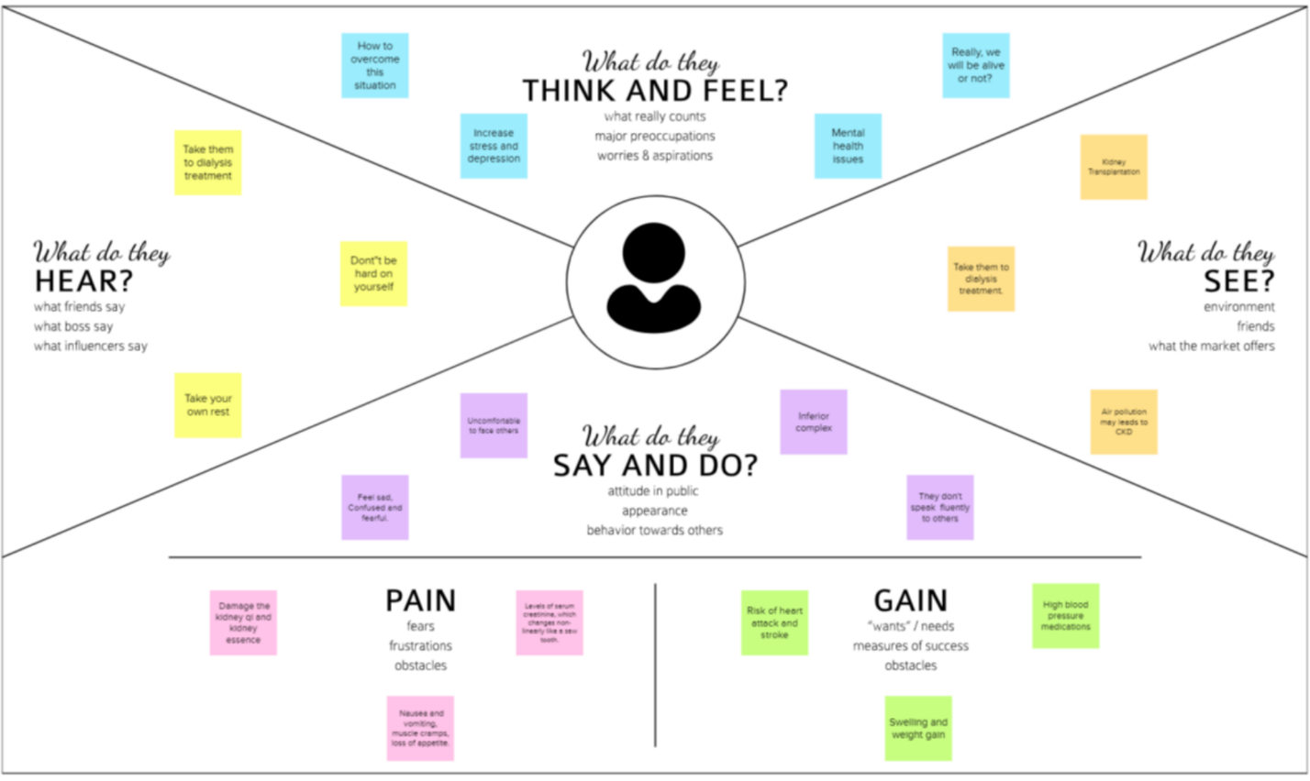

* 1. **Ideation & Brainstorming:**

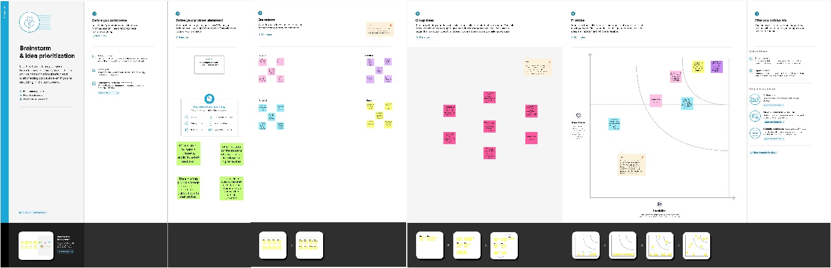

* 1. **Proposed Solution:**

|  |  |  |
| --- | --- | --- |
| **S.No.** | **Parameter** | **Description** |
| 1. | Problem Statement (Problem to be solved) | Patients who suffer from chronic kidney diseases need a way to control its progression to an advanced state with early detection and appropriate treatment. Machine learning has advanced to the point that it is now possible to look through patient medical information and identify chronic kidney disease in its early stages. |
| 2. | Idea / Solution description | Since certain data are missing, the initial step is to perform pre-processing by cleaning the dataset, along with scaling and normalisation of values. The next step is to use dimensionality reduction to identify the key features in the dataset and to remove any irrelevant ones. To accomplish early detection of chronic kidney disease utilising the indicated key traits, a decision tree model must be fitted. |
| 3. | Novelty / Uniqueness | * An indicator of how well the kidneys is working is the amount of a waste product called creatinine in the blood. By examining this data, early kidney disease can be identified by detecting deviations from the norm. * In the case of healthcare management products, it is especially important to have a UI that is very user-friendly and open to everyone. |
| 4. | Social Impact / Customer Satisfaction | The primary goal of this application is early prediction, and appropriate treatments may be able to prevent or delay the disease's progression to an advanced state. |
| 5. | Business Model (Revenue Model) | * The suggested strategy has the potential to generate income from direct patients as payment for the development of immediate outcomes. * It can also collaborate with the healthcare sector to generate revenue from patients who come in for kidney disease diagnosis. |

* 1. **Problem Solution fit:**

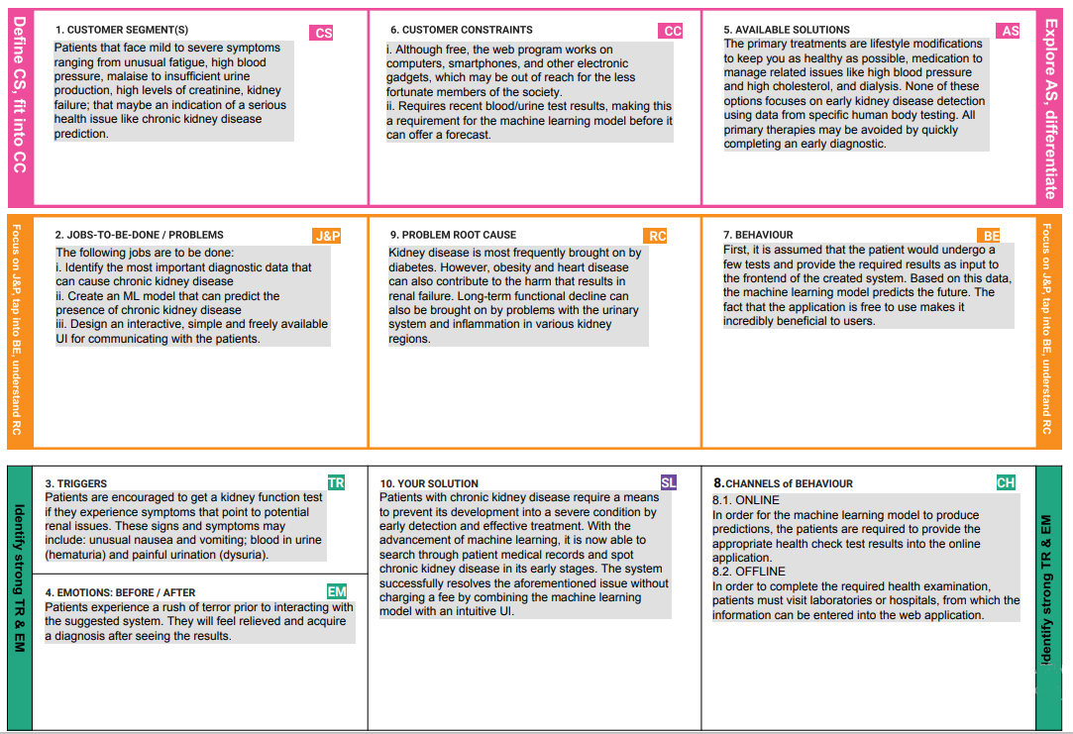

1. **REQUIREMENT ANALYSIS:**
   1. **Functional requirement:**

|  |  |  |
| --- | --- | --- |
| **FR No.** | **Functional Requirement (Epic)** | **Sub Requirement (Story / Sub-Task)** |
| FR-1 | Home Page | * Chronic Kidney disease description * Information about Test Vitals required for prediction * If new User , **REGISTER** * If Already exist, **SIGN IN** |
| FR-2 | User Registration | • Enters Mail ID and other personal details required for Registering. |
| FR-3 | User Login | • Uses Mail ID and Password for login |
| FR-4 | Test Vitals Form | • Test Vitals should be entered for prediction |
| FR-5 | Result | * If Positive – Test Result along with the   Information about what is to be done next will be displayed.   * If Negative – Test result along with preventive measures to prevent themselves from getting Chronic Kidney disease will be displayed. |

**4.2 Non-functional Requirements:**

|  |  |  |
| --- | --- | --- |
| **FR No.** | **Non-Functional Requirement** | **Description** |
| NFR-1 | **Usability** | Even Illiterates and people with no understanding of computer/mobile should be able to use the product. |
| NFR-2 | **Security** | Access permission for particular system information may be changed by systems data administration. |
| NFR-3 | **Reliability** | The database update process must roll back all related updates when any updates fails. |
| NFR-4 | **Performance** | The Home-page load time must be no more than 2 seconds for users that access the website using an LTE mobile connection. |
| NFR-5 | **Availability** | New Model Deployment must not impact Home page ,test page and result page availability and must not take longer than 1 hour. |
| NFR-6 | **Scalability** | The website Traffic limit must be scalable enough to support 2000,000 users at a time. |

**5. PROJECT DESIGN :**

**5.1 Data Flow Diagrams:**

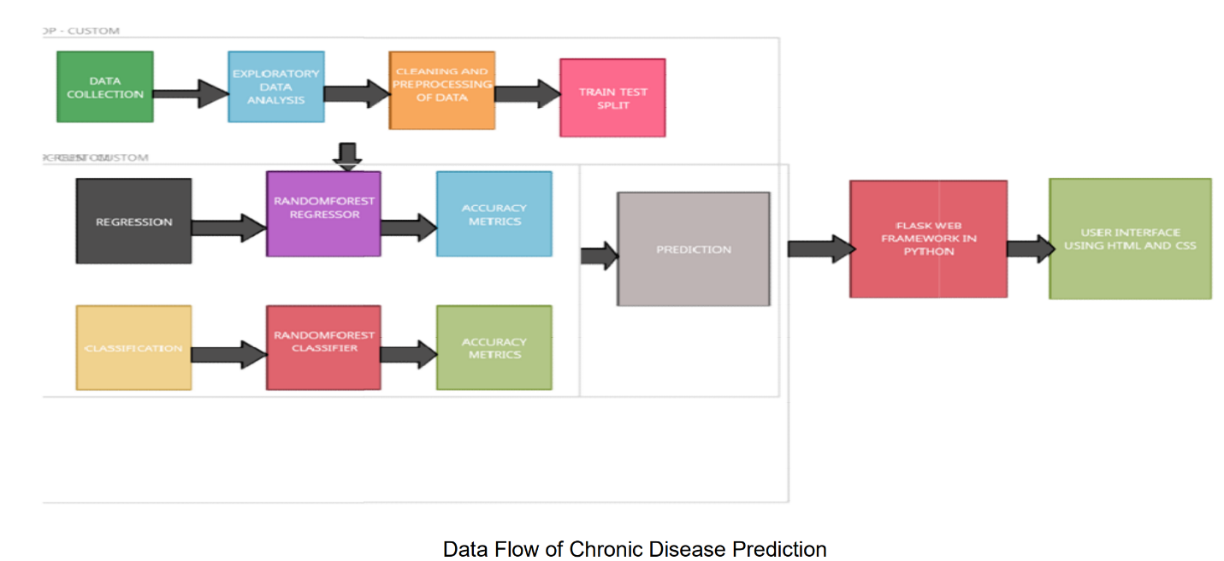

**5.2 Solution & Technical Architecture:**

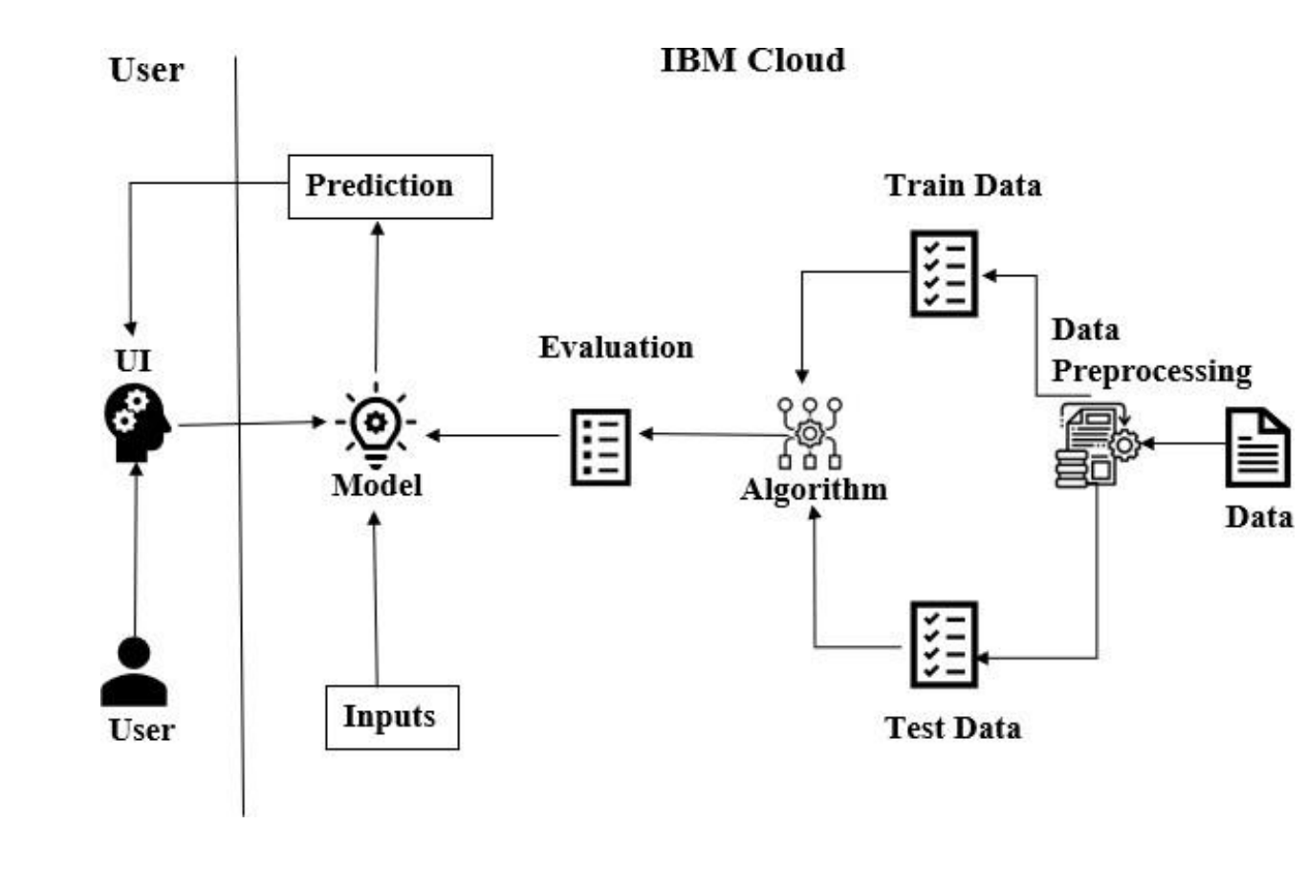

**5.3 User Stories:**

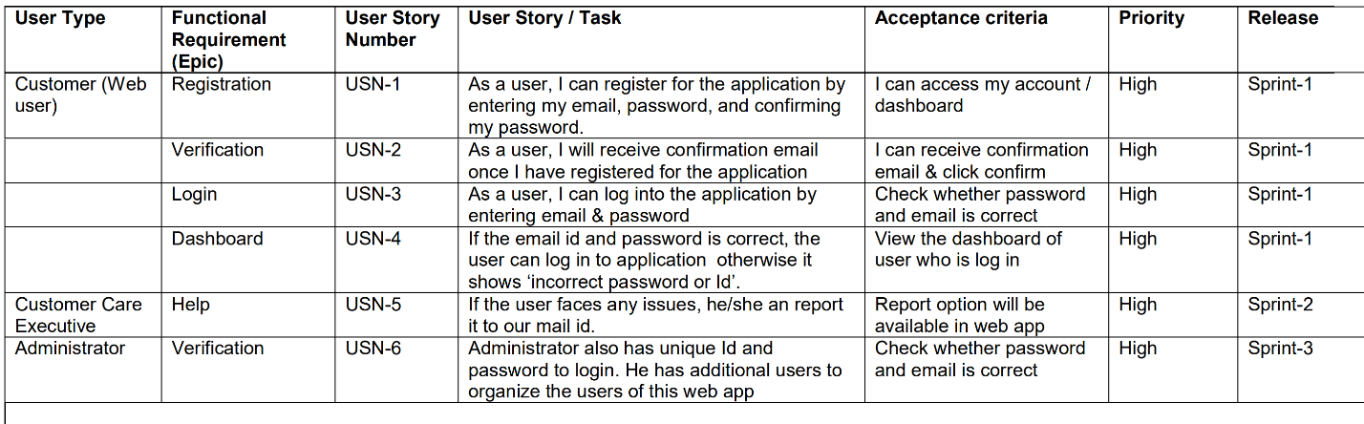

**6. PROJECT PLANNING & SCHEDULING:**

**6.1 Sprint Planning & Estimation:**

|  |  |  |
| --- | --- | --- |
| TITLE | DESCRIPTION | DATE |
| Literature Survey &  Information Gathering | Literature survey on the selected project & gathering information by referring the technical papers, research publications , journals etc. | 1 SEPTEMBER 2022 |
| Prepare Empathy Map | Prepare Empathy Map Canvas to capture the user Pains & Gains, Prepare list of problem Statements that are to be solved by this project. | 8 SEPTEMBER 2022 |
| Ideation | List the ideas by organizing a brainstorming session and prioritize the top 3 ideas based on the feasibility & importance. | 15 SEPTEMBER 2022 |
| Proposed Solution | Prepare the proposed solution document, which includes novelty, feasibility of idea, revenue model, social impact, scalability of solution, etc. | 21 SEPTEMBER 2022 |
| Problem Solution Fit | Prepare problem - solution fit document. | 30 SEPTEMBER 2022 |
| Solution Architecture | Prepare solution architecture document. | 28 SEPTEMBER 2022 |
| Customer Journey | Prepare the customer journey maps to understand the user interactions & experiences with the application (entry to exit). | 5 OCTOBER 2022 |
| Functional Requirement | Prepare the functional requirement document. | 12 OCTOBER 2022 |
| Data Flow Diagrams | Draw the data flow diagrams and submit for review. | 12 OCTOBER 2022 |
| Technology Architecture | Prepare the technology architecture diagram. | 13 OCTOBER 2022 |
| Prepare Milestone & Activity  List | Prepare the milestones & activity list of the project. | 22 OCTOBER 2022 |
| Project Development -  Delivery of Sprint-1, 2, 3 & 4 | Develop & submit the developed code by testing it. | IN PROGRESS.. |

**6.2 Sprint Delivery Schedule:**



**7. CODING & SOLUTIONING:**

**INDEX.HTML:**

<**html**>  
<**head**>  
<**meta name="viewport" content="width=device-width, initial-scale=1.0"**>  
<**title**>Early Detection of Chronic Kidney Disease using Machine Learning</**title**>  
<**link rel="stylesheet" href="static/style.css"**>  
<**link href="https://fonts.googleapis.com/css?family=Poppins:100,200,300,400,600,700&display=swap" rel="stylesheet"**>  
<**link rel="stylesheet" href="https://stackpath.bootstrapcdn.com/font-awesome/4.7.0/css/font-awesome.min.css"**>   
</**head**>  
<**body**>  
 <**section class="header"**>  
   
 <**nav**>  
 <**a href="/"**><**img src="static/images/images.png"**></**a**>  
 <**div class="nav-links" id="navLinks"**>   
 <**i class="fa fa-close" onclick="hideMenu()"**></**i**>  
 <**ul**>  
 <**li**><**a href="/"**>HOME</**a**></**li**>  
 <**li**><**a href="/about"**>ABOUT</**a**></**li**>  
 <**li**><**a href="/Prediction"**>PREDICTION</**a**></**li**>  
 <**li**><**a href="/result"**>RESULT</**a**></**li**>  
 <**li**><**a href="/contact"**>CONTACT</**a**></**li**>  
 </**ul**>  
 </**div**>  
 <**i class="fa fa-bars" onclick="showMenu()"**></**i**>  
 </**nav**>  
   
 <**div class="text-box"**>  
 <**h1**>An Early Detection Can Save Many Lives</**h1**>  
 <**p**>Early Detection of Chronic Kidney Disease using Machine earning</**p**>  
 <**a href="/contact" class="hero-btn"**>Visit Us to Know More</**a**>  
 </**div**>  
 </**section**>  
   
  
   
  
*<!---------- Symptoms ---------->* <**section class="facility"**>  
 <**h1**>Symptoms</**h1**>  
 <**p**>Generally symptoms are not shown explicitly. Some of them are,</**p**>  
 <**div class="row"**>  
 <**div class="facility-col"**>  
 <**img src="static/images/bp.png"**>  
 <**h3**>High BP and Chest pain</**h3**>  
 <**p**>High blood pressure is the major symptom of kidney disease</**p**>  
 </**div**>  
 <**div class="facility-col"**>  
 <**img src="static/images/swe.png"**>  
 <**h3**>Swelling of legs and ankels</**h3**>  
 <**p**>Swelling of legs occurs because of Diabetes mellitus</**p**>  
 </**div**>  
 <**div class="facility-col"**>  
 <**img src="static/images/creatinine.png"**>  
 <**h3**>Urinating more or less</**h3**>  
 <**p**>The presence of creatinine in blood sample indicates the CKD</**p**>  
 </**div**>  
 </**div**>  
 </**section**>  
   
   
*<!---------- causes ----------->* <**section class="course"**>  
 <**h1**>Causes of Chronic Kidney Disease</**h1**>  
 <**p**></**p**>  
 <**div class="row"**>  
 <**div class="course-col"**>  
 <**h3**>Type 1 or type 2 diabetes</**h3**>  
 <**p**>Diabetes is the leading cause of kidney failure</**p**>  
 </**div**>  
 <**div class="course-col"**>  
 <**h3**>Glomerulonephritis</**h3**>  
 <**p**>An inflammation of the kidney's filtering units</**p**>  
 </**div**>  
 <**div class="course-col"**>  
 <**h3**>Vesicoureteral</**h3**>  
 <**p**>A condition that causes urine to back up into your kidneys</**p**>  
 </**div**>  
 </**div**>  
 </**section**>  
   
   
   
*<!-------- footer ---------->*<**section class="footer"**>  
 <**h4**>About Us</**h4**>  
 <**p**>The only way to find out if people have CKD is through simple blood and urine tests.  
 The blood test checks for the level of creatinine, a waste product produced by muscles, to see how well the kidneys work. The urine test checks for protein, which may indicate kidney damage.</**p**>  
   
 <**a href="https://www.sk2bt.com" class="footer-link"**><**p**>Made with <**i class="fa fa-heart-o"**></**i**> by PNT2022TMID01412</**p**></**a**>  
</**section**>   
   
   
*<!----JavaScript for toggle menu---->*<**script**>  
 var navLinks = document.getElementById("navLinks");  
  
 function showMenu() {  
 navLinks.style.right = "0";  
 }  
  
 function hideMenu() {  
 navLinks.style.right = "-200px";  
 }  
</**script**>   
   
</**body**>  
</**html**>

**ABOUT.HTML:**

<**html**>  
<**head**>  
<**meta name="viewport" content="width=device-width, initial-scale=1.0"**>  
<**title**>Early Detection of Chronic Kidney Disease using Machine Learning</**title**>  
<**link rel="stylesheet" href="static/style.css"**>  
<**link href="https://fonts.googleapis.com/css?family=Poppins:100,200,300,400,600,700&display=swap" rel="stylesheet"**>  
<**link rel="stylesheet" href="https://stackpath.bootstrapcdn.com/font-awesome/4.7.0/css/font-awesome.min.css"**>   
</**head**>  
<**body**>  
 <**section class="sub-header"**>  
 <**nav**>  
 <**a href="/"**><**img src="static/images/images.png"**></**a**>  
 <**div class="nav-links" id="navLinks"**>   
 <**i class="fa fa-close" onclick="hideMenu()"**></**i**>  
 <**ul**>  
 <**li**><**a href="/"**>HOME</**a**></**li**>  
 <**li**><**a href="/about"**>ABOUT</**a**></**li**>  
 <**li**><**a href="/Prediction"**>PREDICTION</**a**></**li**>  
 <**li**><**a href="/result"**>RESULT</**a**></**li**>  
 <**li**><**a href="/contact"**>CONTACT</**a**></**li**>  
 </**ul**>  
 </**div**>  
 <**i class="fa fa-bars" onclick="showMenu()"**></**i**>  
 </**nav**>   
 <**h1**>About Us</**h1**>  
 </**section**>  
   
   
*<!------- about us content -------->*<**section class="about-us"**>  
 <**div class="row"**>  
 <**div class="about-col"**>  
 <**h1**>Chronic Kidney Disease using Machine Learning</**h1**>   
 <**p**>The only way to find out if people have CKD is through simple blood and urine tests. The blood test checks for the level of creatinine, a waste product produced by muscles,  
 to see how well the kidneys work. The urine test checks for protein, which may indicate kidney damage.</**p**>  
 <**a href="https://www.youtube.com/c/EasyTutorialsVideo?sub_confirmation=1" class="hero-btn red-btn"**>EXPOLER NOW</**a**>  
 </**div**>  
 <**div class="about-col"**>  
 <**img src="static/images/about1.jpg"**>  
 </**div**>  
 </**div**>   
</**section**>  
   
*<!-------- footer ---------->*<**section class="footer"**>  
 <**h4**>About Us</**h4**>  
 <**p**>The only way to find out if people have CKD is through simple blood and urine tests. The blood test checks for the level of creatinine,</**p**>  
 <**p**> a waste product produced by muscles, to see how well the kidneys work. The urine test checks for protein, which may indicate kidney damage.</**p**>  
 <**div class="icons"**>  
 <**i class="fa fa-facebook"**></**i**>  
 <**i class="fa fa-twitter"**></**i**>  
 <**i class="fa fa-instagram"**></**i**>  
 <**i class="fa fa-linkedin"**></**i**>  
 </**div**>  
 <**p**>Made with <**i class="fa fa-heart-o"**></**i**> by PNT2022TMID01412</**p**>  
</**section**>   
   
   
*<!----JavaScript for toggle menu---->*<**script**>  
 var navLinks = document.getElementById("navLinks");  
  
 function showMenu() {  
 navLinks.style.right = "0";  
 }  
  
 function hideMenu() {  
 navLinks.style.right = "-200px";  
 }  
</**script**>   
   
</**body**>  
</**html**>

**PREDICATION.HTML:**

<**html**>  
<**head**>  
<**meta name="viewport" content="width=device-width, initial-scale=1.0"**>  
<**title**>Early Detection of Chronic Kidney Disease using Machine Learning</**title**>  
<**link rel="stylesheet" href="static/style.css"**>  
<**link href="https://fonts.googleapis.com/css?family=Poppins:100,200,300,400,600,700&display=swap" rel="stylesheet"**>  
<**link rel="stylesheet" href="https://stackpath.bootstrapcdn.com/font-awesome/4.7.0/css/font-awesome.min.css"**>  
</**head**>  
<**body**>  
 <**section class="sub-header"**>  
 <**nav**>  
 <**a href="/"**><**img src="static/images/images.png"**></**a**>  
 <**div class="nav-links" id="navLinks"**>  
 <**i class="fa fa-close" onclick="hideMenu()"**></**i**>  
 <**ul**>  
 <**li**><**a href="/"**>HOME</**a**></**li**>  
 <**li**><**a href="/about"**>ABOUT</**a**></**li**>  
 <**li**><**a href="/Prediction"**>PREDICTION</**a**></**li**>  
 <**li**><**a href="/result"**>RESULT</**a**></**li**>  
 <**li**><**a href="/contact"**>CONTACT</**a**></**li**>  
 </**ul**>  
 </**div**>  
 <**i class="fa fa-bars" onclick="showMenu()"**></**i**>  
 </**nav**>  
   
 </**section**>  
   
*<!---------- Blog Page Content ---------->* <**section class="blog-content"**>  
 <**div class="row"**>  
 <**div class="blog-left"**>  
 <**img src="static/images/prediction.jpg"**>  
 <**h2**>Early Detection of Chronic Kidney Disease</**h2**>  
   
 <**p**>Living with diabetes is difficult, thinking about what you eat. But controlling the sugar levels are really important for helping kidney function and specifically slowing down any damage to the kidneys. Newer drugs that have come out in the last couple years can help with this, as well as working with your primary care physician or endocrinologist with your current therapies to get better sugar control.  
  
We really want to help your health and so losing weight can be a key component to reducing your risk of progressing with kidney disease. Reducing calorie intake, which is either smaller portions, less snacking in between meals, and then thinking about burning calories with increasing your exercise, are great steps forward in starting that journey towards weight loss.  
  
We look to get blood pressure less than 130 systolic, that's the top number. And less than 80 diastolic, that's the bottom number, on blood pressure readings. There are a number of different drugs that we can use to do this. And this will help both with your cardiovascular health, but slowing down any kidney disease progression over time as well.</**p**>  
 <**br**>  
   
   
   
 <**div class="blog-right"**>  
   
   
 <**h3**>CKD Categories</**h3**>  
 <**div**>  
 <**span**>Stage 1 Normal</**span**>  
 <**span**>GFR>90mL/min</**span**>  
 </**div**>  
 <**div**>  
 <**span**>Stage 2 Mild CKD</**span**>  
 <**span**>GFR=60-89mL/min</**span**>  
 </**div**>  
 <**div**>  
 <**span**>Stage 3A Moderate CKD</**span**>  
 <**span**>GFR=45-59mL/min</**span**>  
 </**div**>  
 <**div**>  
 <**span**>Stage 3B Moderate CKD</**span**>  
 <**span**>GFR=30-44mL/min</**span**>  
 </**div**>  
 <**div**>  
 <**span**>Stage 4 Severe CKD</**span**>  
 <**span**>GFR=15-29mL/min</**span**>  
 </**div**>  
 <**div**>  
 <**span**>Stage 5 End Stage CKD</**span**>  
 <**span**>GFR<15mL/min</**span**>  
 </**div**>  
   
 </**div**>   
   
 </**div**>  
 </**section**>  
   
   
   
<**form action="{{url_for('predict')}}" method="POST"**>  
   
 <**section** >  
 <**div class="row"**>  
 <**form id="appointment-form" role="form" method="post" action="#"**>  
  
  
 <**div style="background-color:pink;text-align: center;"**>  
 <**h1**><**strong**>Chronic Kidney Disease</**strong**></**h1**><**h3**>Machine Learning </**h3**>  
 </**div**>  
 <**br**/>  
 <**br**/>  
 <**div**>  
 <**div class="col-md-6 col-sm-6"**>  
 <**label for="name"**>Blood Urea</**label**>  
 <**input type="number" class="form-control" id="name" name="blood_urea" placeholder="Blood Urea Level"**>  
 </**div**>  
  
 <**div class="col-md-6 col-sm-6"**>  
 <**label for="name"**>Blood Glucose Random</**label**>  
 <**input type="number" class="form-control" id="name1" name="blood_glucose_random" placeholder="Blood Glucose Level Random"**>  
 </**div**>  
  
 <**div class="col-md-6 col-sm-6"**>  
 <**label for="select"**>Select Anemia</**label**>  
 <**select name = "Anemia"**>  
 <**option value = "yes"**> yes</**option**>  
 <**option value = "no"**>no </**option**>  
 </**select**>  
 </**div**>  
  
 <**div class="col-md-6 col-sm-6"**>  
 <**label for="select"**>Select Coronary Artery Disease</**label**>  
 <**select name = "coronary_artery_disease"**>  
 <**option value = "yes"**> yes</**option**>  
 <**option value = "no"**>no </**option**>  
 </**select**>  
 </**div**>  
  
 <**div class="col-md-6 col-sm-6"**>  
 <**label for="select"**>Select Pus Cell</**label**>  
 <**select name = "pus_cell"**>  
 <**option value = "yes"**> yes</**option**>  
 <**option value = "no"**>no </**option**>  
 </**select**>  
 </**div**>  
  
 <**div class="col-md-6 col-sm-6"**>  
 <**label for="select"**>Select Red Blood Cell</**label**>  
 <**select name = "red_blood_cell"**>  
 <**option value = "yes"**> yes</**option**>  
 <**option value = "no"**>no </**option**>  
 </**select**>  
 </**div**>  
   
 <**div class="col-md-6 col-sm-6"**>  
 <**label for="select"**>Select Diabetics Mellitus</**label**>  
 <**select name = "diabetics_mellitus"**>  
 <**option value = "yes"**> yes</**option**>  
 <**option value = "no"**>no </**option**>  
 </**select**>  
 </**div**>  
  
 <**div class="col-md-6 col-sm-6"**>  
 <**label for="select"**>Select Pedal Edema</**label**>  
 <**select name = "pedal_edema"**>  
 <**option value = "yes"**> yes</**option**>  
 <**option value = "no"**>no </**option**>  
 </**select**>  
 </**div**>  
 <**div class="col-md-12 col-sm-12"**>  
 <**button type="submit" class="form-control" id="cf-submit" name="submit"**>predict</**button**>  
  
 </**div**>  
 </**div**>  
 </**form**>  
   
 </**div**>  
 </**section**>  
   
*<!-------- footer ---------->*<**section class="footer"**>  
 <**h4**>About Us</**h4**>  
 <**p**>The only way to find out if people have CKD is through simple blood and urine tests. The blood test checks for the level of creatinine, a waste product produced by muscles, to see how well the kidneys work. The urine test checks for protein, which may indicate kidney damage.</**p**>  
 <**div class="icons"**>  
 <**i class="fa fa-facebook"**></**i**>  
 <**i class="fa fa-twitter"**></**i**>  
 <**i class="fa fa-instagram"**></**i**>  
 <**i class="fa fa-linkedin"**></**i**>  
 </**div**>  
 <**p**>made with <**i class="fa fa-heart-o"**></**i**> by PNT2022TMID01412</**p**>  
</**section**>   
   
   
*<!----JavaScript for toggle menu---->*<**script**>  
 var navLinks = document.getElementById("navLinks");  
  
 function showMenu() {  
 navLinks.style.right = "0";  
 }  
  
 function hideMenu() {  
 navLinks.style.right = "-200px";  
 }  
</**script**>   
   
</**body**>  
</**html**>

**RESULT.HTML:**

<**html**>  
<**head**>  
<**meta name="viewport" content="width=device-width, initial-scale=1.0"**>  
<**title**>Early Detection of Chronic Kidney Disease using Machine Learning</**title**>  
<**link rel="stylesheet" href="static/style.css"**>  
<**link href="https://fonts.googleapis.com/css?family=Poppins:100,200,300,400,600,700&display=swap" rel="stylesheet"**>  
<**link rel="stylesheet" href="https://stackpath.bootstrapcdn.com/font-awesome/4.7.0/css/font-awesome.min.css"**>   
</**head**>  
<**body id="top"**>  
 <**section class="sub-header"**>  
 <**nav**>  
 <**a href="/"**><**img src="static/images/images.png"**></**a**>  
 <**div class="nav-links" id="navLinks"**>   
 <**i class="fa fa-close" onclick="hideMenu()"**></**i**>  
 <**ul**>  
 <**li**><**a href="/"**>HOME</**a**></**li**>  
 <**li**><**a href="/about"**>ABOUT</**a**></**li**>  
 <**li**><**a href="/Prediction"**>PREDICTION</**a**></**li**>  
 <**li**><**a href="/result"**>RESULT</**a**></**li**>  
 <**li**><**a href="/contact"**>CONTACT</**a**></**li**>  
 </**ul**>  
 </**div**>  
 <**i class="fa fa-bars" onclick="showMenu()"**></**i**>  
 </**nav**>  
 <**h1**>Prediction Result</**h1**>  
 </**section**>  
   
   
<**section**>  
 <**div class="container"**>  
 <**div class="row"**>  
   
 <**div style="background-color:pink;text-align: center;"**>  
 <**h1**>Chronic Kidney Disease</**h1**><**h3**>Machine Learning Web Application</**h3**>  
 </**div**>  
 <**br**/>  
 <**br**/>  
  
 <**div class="col-md-8 col-sm-7"**>  
 {{prediction_text}}  
 {% if prediction_text==1%}  
  
 <**div** >  
 <**h2**>Medical Result</**h2**>  
 <**p**>Your Condition is normal.</**p**>  
 <**blockquote**>You are not having chronic kidney disease.</**blockquote**>  
 <**img src="static\images\result2.jpg" width="300" height="300"**/>  
 <**p**></**p**>  
   
 </**div**>  
 {%else%}  
 <**div** >  
 <**h2**>Medical Result</**h2**>  
 <**p**>Your Condition is abnormal.</**p**>  
 <**blockquote**>You are having chronic kidney disease.</**blockquote**>  
 <**img src="static\images\result1.jpg" width="300" height="300"**/>  
 <**p**></**p**>  
  
 </**div**>  
 {% endif %}  
  
 </**div**>  
  
 <**div class="col-md-4 col-sm-5"**>  
 <**div class="news-sidebar"**>  
   
 </**div**>  
 </**div**>  
   
 </**div**>  
 </**div**>  
 </**section**>  
   
*<!-------- footer ---------->*<**section class="footer"**>  
 <**h4**>About Us</**h4**>  
 <**p**>The only way to find out if people have CKD is through simple blood and urine tests. The blood test checks for the level of creatinine, a waste product produced by muscles, to see how well the kidneys work. The urine test checks for protein, which may indicate kidney damage.</**p**>  
 <**div class="icons"**>  
 <**i class="fa fa-facebook"**></**i**>  
 <**i class="fa fa-twitter"**></**i**>  
 <**i class="fa fa-instagram"**></**i**>  
 <**i class="fa fa-linkedin"**></**i**>  
 </**div**>  
 <**p**>made with <**i class="fa fa-heart-o"**></**i**> by PNT2022TMID01412</**p**>  
</**section**>   
   
   
*<!----JavaScript for toggle menu---->*<**script**>  
 var navLinks = document.getElementById("navLinks");  
  
 function showMenu() {  
 navLinks.style.right = "0";  
 }  
  
 function hideMenu() {  
 navLinks.style.right = "-200px";  
 }  
</**script**>   
   
</**body**>  
</**html**>

**CONTACT.HTML:**

<**html**>  
<**head**>  
<**meta name="viewport" content="width=device-width, initial-scale=1.0"**>  
<**title**>Early Detection of Chronic Kidney Disease using Machine Learning</**title**>  
<**link rel="stylesheet" href="style.css"**>  
<**link href="https://fonts.googleapis.com/css?family=Poppins:100,200,300,400,600,700&display=swap" rel="stylesheet"**>  
<**link rel="stylesheet" href="https://stackpath.bootstrapcdn.com/font-awesome/4.7.0/css/font-awesome.min.css"**>   
</**head**>  
<**body**>  
 <**section class="sub-header"**>  
 <**nav**>  
 <**a href="/"**><**img src="static/images/images.png"**></**a**>  
 <**div class="nav-links" id="navLinks"**>   
 <**i class="fa fa-close" onclick="hideMenu()"**></**i**>  
 <**ul**>  
 <**li**><**a href="/"**>HOME</**a**></**li**>  
 <**li**><**a href="/about"**>ABOUT</**a**></**li**>  
 <**li**><**a href="/Prediction"**>PREDICTION</**a**></**li**>  
 <**li**><**a href="/result"**>RESULT</**a**></**li**>  
 <**li**><**a href="/contact"**>CONTACT</**a**></**li**>  
 </**ul**>  
 </**div**>  
 <**i class="fa fa-bars" onclick="showMenu()"**></**i**>  
 </**nav**>  
 <**h1**>Contact Us</**h1**>  
 </**section**>  
   
   
*<!------- Contact Us ------->* <**section class="location"**>  
 <**iframe src="https://www.google.com/maps/embed?pb=!1m18!1m12!1m3!1d3887.368144678623!2d77.55384341419037!3d13.012212417508028!2m3!1f0!2f0!3f0!3m2!1i1024!2i768!4f13.1!3m3!1m2!1s0x3bae3d7f3535d71b%3A0x660d25b66e9fb25c!2sWorld+Trade+Centre!5e0!3m2!1sen!2sin!4v1565255080367!5m2!1sen!2sin" width="720" height="445" frameborder="0" style="border:0" allowfullscreen**></**iframe**>  
 </**section**>  
   
 <**section class="contact-us"**>  
 <**div class="row"**>  
 <**div class="contact-col"**>  
 <**div**>  
 <**i class="fa fa-home"**></**i**>  
 <**span**>  
 <**h5**> Panimalar Engineering College</**h5**>  
 <**p**>Chennai,TamilNadu,India</**p**>  
 </**span**>  
 </**div**>  
 <**div**>  
 <**i class="fa fa-phone"**></**i**>  
 <**span**>  
 <**h5**>+1 0123456789</**h5**>  
 <**p**>Monday to Saturday 10 Am to 6 Pm</**p**>  
 </**span**>  
 </**div**>  
 <**div**>  
 <**i class="fa fa-envelope-o"**></**i**>  
 <**span**>  
 <**h5**>info@pnt2022tmid01412.com</**h5**>  
 <**p**>Email us your query</**p**>  
 </**span**>  
 </**div**>  
 </**div**>  
 <**div class="contact-col"**>  
 <**form method="post" action="contact-form-handler.php"**>  
 <**input type="text" name="name" placeholder="Enter your name" required**>  
 <**input type="email" name="email" placeholder="Enter email address" required**>  
 <**input type="text" name="subject" placeholder="Enter your subject" required**>  
 <**textarea rows="8" name="message" placeholder="Message" required**></**textarea**>  
 <**button type="submit" class="hero-btn red-btn"**>Send Message</**button**>  
 </**form**>   
 </**div**>  
 </**div**>  
 </**section**>  
   
*<!-------- footer ---------->*<**section class="footer"**>  
 <**h4**>About Us</**h4**>  
 <**p**>The only way to find out if people have CKD is through simple blood and urine tests. The blood test checks for the level of creatinine, a waste product  
 produced by muscles, to see how well the kidneys work. The urine test checks for protein, which may indicate kidney damage.</**p**>  
 <**div class="icons"**>  
 <**i class="fa fa-facebook"**></**i**>  
 <**i class="fa fa-twitter"**></**i**>  
 <**i class="fa fa-instagram"**></**i**>  
 <**i class="fa fa-linkedin"**></**i**>  
 </**div**>  
 <**p**>made with <**i class="fa fa-heart-o"**></**i**> by PNT2022TMID01412</**p**>  
</**section**>   
   
   
*<!----JavaScript for toggle menu---->*<**script**>  
 var navLinks = document.getElementById("navLinks");  
  
 function showMenu() {  
 navLinks.style.right = "0";  
 }  
  
 function hideMenu() {  
 navLinks.style.right = "-200px";  
 }  
</**script**>   
   
</**body**>  
</**html**>

**APP.PY:**

**import** numpy **as** np  
**import** pandas **as** pd  
**import** sklearn  
**from** flask **import** Flask, request, render_template  
**import** pickle5 **as** pickle  
  
  
app = Flask(__name__)  
model = pickle.load(open(**'Models/modeling.pkl'**, **'rb'**))  
  
  
@app.route(**'/'**)  
**def** home():  
 **return** render_template(**'index.html'**)  
  
  
@app.route(**'/Prediction'**, methods=[**'POST'**, **'GET'**])  
**def** prediction():  
 **return** render_template(**'prediction.html'**)  
  
  
@app.route(**'/Home'**, methods=[**'POST'**, **'GET'**])  
**def** my_home():  
 **return** render_template(**'index.html'**)  
  
@app.route(**'/result'**, methods=[**'POST'**, **'GET'**])  
**def** result():  
 **return** render_template(**'result.html'**)  
  
@app.route(**'/predict'**, methods=[**'POST'**])  
**def** predict():  
 x=input()  
 input_features = ([int(x) **for** x **in** request.form.values()])  
 blood_urea = request.form[**"blood_urea"**]  
 blood_glucose_random = request.form[**"blood_glucose_random"**]  
 anemia = request.form[**"Anemia"**]  
 **if** (anemia == **"no"**):  
 anemia = 0  
 **if** (anemia == **"yes"**):  
 anemia = 1  
 coronary_artery_disease = request.form[**"coronary_artery_disease"**]  
 **if** (coronary_artery_disease == **"no"**):  
 coronary_artery_disease = 0  
 **if**(coronary_artery_disease == **"yes"**):  
 coronary_artery_disease = 1  
  
 pus_cell = request.form[**"pus_cell"**]  
 **if** (pus_cell == **"no"**):  
 pus_cell = 0  
 **if** (pus_cell == **"yes"**):  
 pus_cell = 1  
  
 red_blood_cell = request.form[**"red_blood_cell"**]  
 **if** (red_blood_cell == **"no"**):  
 red_blood_cell = 0  
 **if** (red_blood_cell == **"yes"**):  
 red_blood_cell = 1  
  
 diabetics_mellitus = request.form[**"diabetics_mellitus"**]  
 **if** (diabetics_mellitus == **"no"**):  
 diabetics_mellitus = 0  
 **if** (diabetics_mellitus == **"yes"**):  
 diabetics_mellitus = 1  
  
 pedal_edema = request.form[**"pedal_edema"**]  
 **if** (pedal_edema == **"no"**):  
 pedal_edema = 0  
 **if** (pedal_edema == **"yes"**):  
 pedal_edema = 1  
  
 input_features = [int(blood_urea),int(blood_glucose_random),int(anemia),int(coronary_artery_disease),int(pus_cell),int(red_blood_cell),int(diabetics_mellitus),int(pedal_edema)]  
 input_features = [int(red_blood_cell),int(pus_cell),int(blood_glucose_random),int(blood_urea),int(pedal_edema),int(anemia),int(diabetics_mellitus),int(coronary_artery_disease)]  
 print(input_features)  
 features_value = [np.array(input_features)]  
  
  
 features_name = [**'red_blood_cells'**,**'pus_cell'**,**'blood glucose random'**,**'blood_urea'**,**'pedal_edema'**,**'anemia'**,**'diabetesmellitus'**,**'coronary_artery_disease'**]  
 features_name = [**'blood_urea'**,**'blood glucose random'**,**'anemia'**,**'coronary_artery_disease'**,**'pus_cell'**,**'red_blood_cells'**,**'diabetesmellitus'**,**'pedal_edema'** ]  
 df = pd.DataFrame(features_value, columns=features_name)  
 output = model.predict(df)  
 **return** render_template(**'result.html'**, prediction_text=output)  
  
@app.route(**'/about'**)  
**def** about():  
 **return** render_template(**'about.html'**)  
  
@app.route(**'/contact'**)  
**def** contact():  
 **return** render_template(**'contact.html'**)  
  
*# Press the green button in the gutter to run the script.***if** __name__ == **'__main__'**:  
 app.run(host=**'localhost'**, debug=**True**)

**STYLE.CSS:**

*{  
 margin: 0;  
 padding: 0;  
 font-family: **'Poppins'**, sans-serif;  
}  
.header{  
 min-height: 100vh;  
 width: 100%;  
 background-image: linear-gradient(rgba(4,9,30,0.7),rgba(4,9,30,0.7)),url(images/about1.png);  
 background-position: center;  
 background-size: cover;  
 position: relative;  
 overflow: hidden;  
}  
  
nav{  
 display: flex;  
 padding: 2% 4%;  
 justify-content: space-between;  
 align-items: center;  
}  
nav img{  
 width: 135px;  
}  
.nav-links{  
 flex: 1;  
 text-align: right;  
}  
.nav-links ul li{  
 list-style: none;  
 display: inline-block;  
 padding: 8px 12px;  
 position: relative;  
}  
.nav-links ul li a{  
 color: #fff;  
 text-decoration: none;  
 font-size: 13px;  
}  
.nav-links ul li::after{  
 content: **''**;  
 width: 0%;  
 height: 2px;  
 background: #f44336;  
 display: block;  
 margin: auto;  
 transition: .5s;   
}  
.nav-links ul li:hover::after{  
 width: 100%;  
}  
nav .fa{  
 display: none;  
}  
  
.text-box{  
 width: 90%;  
 color: #fff;  
 position: absolute;  
 top: 50%;  
 left: 50%;  
 transform: translate(-50%, -50%);  
 text-align: center;  
}  
.text-box h1{  
 font-size: 62px;  
}  
.text-box p{  
 margin: 20px 0 40px;  
 font-size: 14px;  
 color: #fff;  
}  
.hero-btn {  
 display: inline-block;  
 text-decoration: none;  
 color: #fff;  
 border: 1px solid #fff;  
 padding: 12px 34px;  
 font-size: 13px;  
 background: transparent;  
 position: relative;  
 cursor: pointer;  
 transition: 1s;  
}  
  
.hero-btn:hover{  
 border: 1px solid #f44336;  
 background: #f44336;  
}  
  
  
@media(max-width: 700px)  
{  
 .nav-links ul li  
 {  
 display: block;  
 }  
 .nav-links  
 {  
 position: fixed;  
 background: #f44336;  
 height: 100vh;  
 width: 200px;  
 top: 0;  
 right: -200px;  
 text-align: left;  
 z-index: 2;  
 transition: 0.5s;  
 }  
 .nav-links ul{  
 padding: 30px;  
 }  
 nav .fa{  
 display: block;  
 color: #fff;  
 margin: 10px;  
 font-size: 22px;  
 cursor: pointer;   
 }  
 .text-box h1{  
 font-size: 20px;  
 }  
}  
  
*/*---------- course --------*/*.course{  
 width: 80%;  
 margin: auto;  
 text-align: center;  
 padding-top: 100px;  
}  
h1{  
 font-size: 36px;  
 font-weight: 600;  
}  
p{  
 color: #777;  
 font-size: 14px;  
 font-weight: 300;  
 line-height: 22px;  
 padding: 10px;  
}  
.row{  
 margin-top: 5%;  
 display: flex;  
 justify-content: space-between;   
}  
   
.course-col{  
 flex-basis: 31%;  
 background: #fff3f3;  
 border-radius: 10px;  
 margin-bottom: 5%;  
 padding: 20px 12px;  
 box-sizing: border-box;  
 transition: .5s;  
}  
h3{  
 text-align: center;  
 font-weight: 600;  
 margin: 10px 0;  
}  
.course-col:hover{  
 box-shadow: 0 0 20px 0px rgba(0, 0, 0, 0.2);  
}  
  
@media (max-width:700px){  
 .row{  
 flex-direction: column;  
 }  
}   
  
*/*---------------- campus ----------------*/*.campus{  
 width: 80%;  
 margin: auto;  
 text-align: center;  
 padding-top: 50px;  
}  
.campus-col{  
 flex-basis: 32%;  
 border-radius: 10px;  
 margin-bottom: 30px;  
 position: relative;  
 overflow: hidden;  
}  
.campus-col img{  
 width: 100%;  
}  
  
.layer{  
 background: transparent;  
 height: 100%;  
 width: 100%;  
 top: 0;  
 left: 0;  
 position: absolute;  
 transition: .5s;  
}  
.layer:hover{  
 background: rgba(226, 0, 0, 0.7);  
}  
.layer h3{  
 width: 100%;  
 font-weight: 500;  
 color: #fff;  
 font-size: 26px;  
 bottom: 0;  
 left: 50%;  
 transform: translateX(-50%);  
 position: absolute;  
 opacity: 0;  
 transition: .5s;  
}  
.layer:hover h3{  
 bottom: 49%;  
 opacity: 1;  
}  
  
*/*-------------- Facilities ----------------*/*.facility{  
 width: 80%;  
 margin: auto;  
 text-align: center;  
 padding-top: 100px;  
}  
.facility-col{  
 flex-basis: 31%;  
 border-radius: 10px;  
 margin-bottom: 5%;  
 text-align: left;  
}  
.facility-col img{  
 width: 100%;  
 border-radius: 10px;  
}  
.facility-col p{  
 padding: 0;  
}  
.facility-col h3{  
 margin-top: 16px;  
 margin-bottom: 15px;  
 text-align: left;  
}  
  
*/*---------------- testimonials ------------------*/*.testimonials{  
 width: 80%;  
 margin: auto;  
 padding-top: 100px;  
 text-align: center;  
}  
  
.testimonial-col{  
 flex-basis: 44%;  
 border-radius: 10px;  
 margin-bottom: 5%;  
 text-align: left;  
 background: #fff3f3;  
 padding: 25px;  
 cursor: pointer;  
 display: flex;  
}  
.testimonial-col img{  
 height: 40px;  
 margin-left: 5px;  
 margin-right: 30px;  
 border-radius: 50%;  
}  
.testimonial-col p{  
 padding: 0;  
}  
.testimonial-col h3{  
 margin-top: 15px;  
 text-align: left;  
}  
.testimonial-col .fa{  
 color: #f44336;  
}  
  
@media(max-width:700px){  
 .testimonial-col img{  
 margin-left: 0px;  
 margin-right: 15px;  
 }  
}  
  
*/*-------- Call To Action ----------*/*.cta{  
 margin: 100px auto;  
 width: 80%;  
 background-image: linear-gradient(rgba(0,0,0,0.7),rgba(0,0,0,0.7)),url(images/banner2.jpg);  
 background-position: center;  
 background-size: cover;  
 border-radius: 10px;  
 text-align: center;  
 padding: 100px 0;  
}  
.cta h1{  
 color: #fff;  
 margin-bottom: 40px;   
 padding: 0;   
}  
  
@media(max-width:700px){  
 .cta h1{  
 font-size: 24px;  
 }  
}  
  
*/*--------------Footer---------------*/*.footer{  
 width: 100%;  
 text-align: center;  
 padding: 30px 0;  
}  
.footer h4{  
 margin-bottom: 25px;  
 margin-top: 20px;  
 font-weight: 600;  
}  
  
.icons .fa{  
 color: #f44336;  
 margin: 0 13px;  
 cursor: pointer;  
 padding: 18px 0;  
}  
.fa-heart-o{  
 color: #f44336;  
}  
  
  
*/*--------------- About Us Page --------------*/*.sub-header{  
 height: 50vh;  
 width: 100%;  
 background-image: linear-gradient(rgba(4,9,30,0.7),rgba(4,9,30,0.7)),url(images/background.jpg);  
 background-position: center;  
 background-size: cover;  
 text-align: center;  
 color: #fff;  
}  
.sub-header h1{  
 margin-top: 100px;  
}  
.about-us{  
 width: 80%;  
 margin: auto;  
 padding-top: 80px;  
 padding-bottom: 50px;  
}  
  
.about-col{  
 flex-basis: 48%;  
 padding: 30px 2px;  
}  
.about-col h1{  
 padding-top: 0;  
}  
.about-col p{  
 padding: 15px 0 25px;  
}  
  
.hero-btn.red-btn{  
 border: 1px solid #f44336;  
 background: transparent;  
 color: #f44336;  
}  
.hero-btn.red-btn:hover{  
 border: 1px solid #f44336;  
 background: #f44336;  
 color: #fff;  
}  
.hero-btn.red-btn::after{  
 background: #f44336;  
}  
.hero-btn.red-btn::before{  
 background: #f44336;  
}  
.content-image{  
 flex-basis: 50%;  
}  
.about-col img{  
 width: 100%;  
}  
  
*/*---------- Blog Page -------------*/*.blog-content{  
 width: 80%;  
 margin: auto;  
 padding: 60px 0;  
}  
.blog-left{  
 flex-basis: 65%;  
}  
.blog-right{  
 flex-basis: 32%;  
}  
.blog-left img{  
 width: 100%;  
}  
.blog-left h2{  
 color: #222;  
 font-weight: 600;  
 margin: 30px 0;  
}  
.blog-left p{  
 color: #999;  
 padding: 0;  
}  
  
.blog-right h3{  
 background: #f44336;  
 color: #fff;  
 padding: 7px 0;  
 font-size: 16px;  
 margin-bottom: 20px;  
}  
.blog-right div{  
 display: flex;  
 align-items: center;  
 justify-content: space-between;  
 color: #555;  
 padding: 8px;  
 box-sizing: border-box;  
}  
  
.comment-box{  
 border: 1px solid #ccc;  
 margin: 50px 0;  
 padding: 10px 20px;  
}  
  
.comment-box h3{  
 text-align: left;  
}  
.comment-form input, .comment-form textarea{  
 width: 100%;  
 padding: 10px;  
 margin: 15px 0;  
 box-sizing: border-box;  
 border: none;  
 outline: none;  
 background: #f0f0f0;  
}  
.comment-form button{  
 margin: 10px 0;  
}  
  
  
@media (max-width:700px){  
 .sub-header h1{  
 font-size: 24px;  
 }  
}   
  
  
*/*------- Contact Us Page ------------*/*.location{  
 width: 80%;  
 margin: auto;  
 padding: 80px 0;  
}  
.location iframe{  
 width: 100%;  
}  
  
.contact-us{  
 width: 80%;  
 margin: auto;  
}  
.contact-col{  
 flex-basis: 48%;  
 margin-bottom: 30px;  
}  
  
.contact-col div{  
 display: flex;  
 align-items: center;  
 margin-bottom: 40px;  
}  
  
.contact-col div .fa{  
 font-size: 28px;  
 color: #f44336;  
 margin: 10px;  
 margin-right: 30px;  
}  
   
.contact-col div p{  
 padding: 0;  
}  
.contact-col div h5{  
 font-size: 20px;  
 margin-bottom: 5px;  
 color: #555;  
 font-weight: 400;  
   
}  
.contact-col input, .contact-col textarea{  
 width: 100%;  
 padding: 15px;  
 margin-bottom: 17px;  
 outline: none;  
 border: 1px solid #ccc;  
}  
  
.footer-link{  
 text-decoration: none;  
 color: #777;  
}  
  
  
  
  
  
**8. TESTING:**

**8.1 Test Cases:**

A test case has components that describe input, action and an expected response, in order to determine if a feature of an application is working correctly. A test case is a set of instructions on “HOW” to validate a user input is correct or check their crtiriea match our database or not.

**8.2 User Acceptance testing:**

Users, clients, or other authorized organizations conduct this type of testing to determine the specifications and operational practices of an application or piece of software. Acceptance testing is the most important testing phase since it establishes whether or not the customer will accept the application or software. It could involve the user interface, functionality, usability, and usefulness of the application. It is also known as operational acceptance testing, user acceptability testing, and end-user testing (UAT).

**9. RESULTS:**

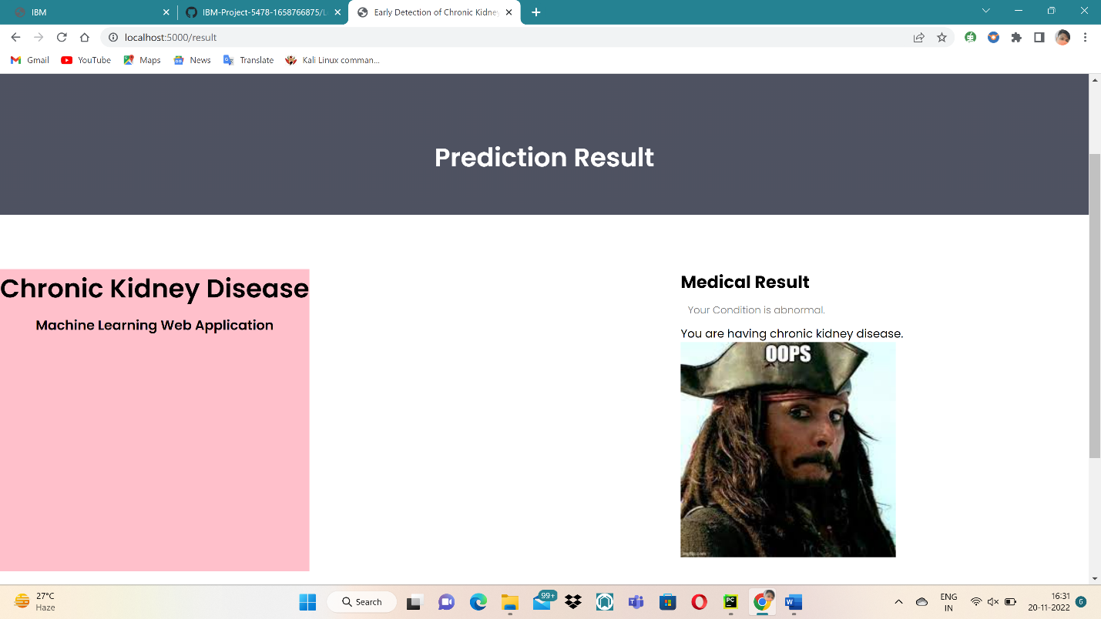

**10. ADVANTAGE AND DISADVANTAGE :**

* This software has several advantages, including the ability to serve as an expert guide to doctors in the early detection of chronic kidney disease. It is also seen in performance metrics that it has an accuracy of 95%, giving users confidence.
* Machine Learning is self-sufficient, but it is prone to errors. Assume you train an algorithm with data sets that are too small to be inclusive. As a result of a biassed training set, you get biassed predictions.

**11. CONCLUSION :**

* This project has guided team members in understanding various concepts of machine learning, Flask file, IBM cloud, and Python notebook.
* Therefore this project can be scaled for use in the prediction of other chronic diseases, which will help doctors in the diagnosis of disease at an early stage, thereby aiding in the early detection of various diseases.

**12. FUTURE SCOPE :**

By modifying the dataset and user inputs, this technology can be used to detect a wide range of other chronic diseases. To improve accuracy, the model can be further trained with huge amounts of data.

# 13. APPENDIX

**Source Code:**

**FRONT-END:**

**INDEX.HTML:**

<**html**>  
<**head**>  
<**meta name="viewport" content="width=device-width, initial-scale=1.0"**>  
<**title**>Early Detection of Chronic Kidney Disease using Machine Learning</**title**>  
<**link rel="stylesheet" href="static/style.css"**>  
<**link href="https://fonts.googleapis.com/css?family=Poppins:100,200,300,400,600,700&display=swap" rel="stylesheet"**>  
<**link rel="stylesheet" href="https://stackpath.bootstrapcdn.com/font-awesome/4.7.0/css/font-awesome.min.css"**>   
</**head**>  
<**body**>  
 <**section class="header"**>  
   
 <**nav**>  
 <**a href="/"**><**img src="static/images/images.png"**></**a**>  
 <**div class="nav-links" id="navLinks"**>   
 <**i class="fa fa-close" onclick="hideMenu()"**></**i**>  
 <**ul**>  
 <**li**><**a href="/"**>HOME</**a**></**li**>  
 <**li**><**a href="/about"**>ABOUT</**a**></**li**>  
 <**li**><**a href="/Prediction"**>PREDICTION</**a**></**li**>  
 <**li**><**a href="/result"**>RESULT</**a**></**li**>  
 <**li**><**a href="/contact"**>CONTACT</**a**></**li**>  
 </**ul**>  
 </**div**>  
 <**i class="fa fa-bars" onclick="showMenu()"**></**i**>  
 </**nav**>  
   
 <**div class="text-box"**>  
 <**h1**>An Early Detection Can Save Many Lives</**h1**>  
 <**p**>Early Detection of Chronic Kidney Disease using Machine earning</**p**>  
 <**a href="/contact" class="hero-btn"**>Visit Us to Know More</**a**>  
 </**div**>  
 </**section**>  
   
  
   
  
*<!---------- Symptoms ---------->* <**section class="facility"**>  
 <**h1**>Symptoms</**h1**>  
 <**p**>Generally symptoms are not shown explicitly. Some of them are,</**p**>  
 <**div class="row"**>  
 <**div class="facility-col"**>  
 <**img src="static/images/bp.png"**>  
 <**h3**>High BP and Chest pain</**h3**>  
 <**p**>High blood pressure is the major symptom of kidney disease</**p**>  
 </**div**>  
 <**div class="facility-col"**>  
 <**img src="static/images/swe.png"**>  
 <**h3**>Swelling of legs and ankels</**h3**>  
 <**p**>Swelling of legs occurs because of Diabetes mellitus</**p**>  
 </**div**>  
 <**div class="facility-col"**>  
 <**img src="static/images/creatinine.png"**>  
 <**h3**>Urinating more or less</**h3**>  
 <**p**>The presence of creatinine in blood sample indicates the CKD</**p**>  
 </**div**>  
 </**div**>  
 </**section**>  
   
   
*<!---------- causes ----------->* <**section class="course"**>  
 <**h1**>Causes of Chronic Kidney Disease</**h1**>  
 <**p**></**p**>  
 <**div class="row"**>  
 <**div class="course-col"**>  
 <**h3**>Type 1 or type 2 diabetes</**h3**>  
 <**p**>Diabetes is the leading cause of kidney failure</**p**>  
 </**div**>  
 <**div class="course-col"**>  
 <**h3**>Glomerulonephritis</**h3**>  
 <**p**>An inflammation of the kidney's filtering units</**p**>  
 </**div**>  
 <**div class="course-col"**>  
 <**h3**>Vesicoureteral</**h3**>  
 <**p**>A condition that causes urine to back up into your kidneys</**p**>  
 </**div**>  
 </**div**>  
 </**section**>  
   
   
   
*<!-------- footer ---------->*<**section class="footer"**>  
 <**h4**>About Us</**h4**>  
 <**p**>The only way to find out if people have CKD is through simple blood and urine tests.  
 The blood test checks for the level of creatinine, a waste product produced by muscles, to see how well the kidneys work. The urine test checks for protein, which may indicate kidney damage.</**p**>  
   
 <**a href="https://www.sk2bt.com" class="footer-link"**><**p**>Made with <**i class="fa fa-heart-o"**></**i**> by PNT2022TMID01412</**p**></**a**>  
</**section**>   
   
   
*<!----JavaScript for toggle menu---->*<**script**>  
 var navLinks = document.getElementById("navLinks");  
  
 function showMenu() {  
 navLinks.style.right = "0";  
 }  
  
 function hideMenu() {  
 navLinks.style.right = "-200px";  
 }  
</**script**>   
   
</**body**>  
</**html**>

**ABOUT.HTML:**

<**html**>  
<**head**>  
<**meta name="viewport" content="width=device-width, initial-scale=1.0"**>  
<**title**>Early Detection of Chronic Kidney Disease using Machine Learning</**title**>  
<**link rel="stylesheet" href="static/style.css"**>  
<**link href="https://fonts.googleapis.com/css?family=Poppins:100,200,300,400,600,700&display=swap" rel="stylesheet"**>  
<**link rel="stylesheet" href="https://stackpath.bootstrapcdn.com/font-awesome/4.7.0/css/font-awesome.min.css"**>   
</**head**>  
<**body**>  
 <**section class="sub-header"**>  
 <**nav**>  
 <**a href="/"**><**img src="static/images/images.png"**></**a**>  
 <**div class="nav-links" id="navLinks"**>   
 <**i class="fa fa-close" onclick="hideMenu()"**></**i**>  
 <**ul**>  
 <**li**><**a href="/"**>HOME</**a**></**li**>  
 <**li**><**a href="/about"**>ABOUT</**a**></**li**>  
 <**li**><**a href="/Prediction"**>PREDICTION</**a**></**li**>  
 <**li**><**a href="/result"**>RESULT</**a**></**li**>  
 <**li**><**a href="/contact"**>CONTACT</**a**></**li**>  
 </**ul**>  
 </**div**>  
 <**i class="fa fa-bars" onclick="showMenu()"**></**i**>  
 </**nav**>   
 <**h1**>About Us</**h1**>  
 </**section**>  
   
   
*<!------- about us content -------->*<**section class="about-us"**>  
 <**div class="row"**>  
 <**div class="about-col"**>  
 <**h1**>Chronic Kidney Disease using Machine Learning</**h1**>   
 <**p**>The only way to find out if people have CKD is through simple blood and urine tests. The blood test checks for the level of creatinine, a waste product produced by muscles,  
 to see how well the kidneys work. The urine test checks for protein, which may indicate kidney damage.</**p**>  
 <**a href="https://www.youtube.com/c/EasyTutorialsVideo?sub_confirmation=1" class="hero-btn red-btn"**>EXPOLER NOW</**a**>  
 </**div**>  
 <**div class="about-col"**>  
 <**img src="static/images/about1.jpg"**>  
 </**div**>  
 </**div**>   
</**section**>  
   
*<!-------- footer ---------->*<**section class="footer"**>  
 <**h4**>About Us</**h4**>  
 <**p**>The only way to find out if people have CKD is through simple blood and urine tests. The blood test checks for the level of creatinine,</**p**>  
 <**p**> a waste product produced by muscles, to see how well the kidneys work. The urine test checks for protein, which may indicate kidney damage.</**p**>  
 <**div class="icons"**>  
 <**i class="fa fa-facebook"**></**i**>  
 <**i class="fa fa-twitter"**></**i**>  
 <**i class="fa fa-instagram"**></**i**>  
 <**i class="fa fa-linkedin"**></**i**>  
 </**div**>  
 <**p**>Made with <**i class="fa fa-heart-o"**></**i**> by PNT2022TMID01412</**p**>  
</**section**>   
   
   
*<!----JavaScript for toggle menu---->*<**script**>  
 var navLinks = document.getElementById("navLinks");  
  
 function showMenu() {  
 navLinks.style.right = "0";  
 }  
  
 function hideMenu() {  
 navLinks.style.right = "-200px";  
 }  
</**script**>   
   
</**body**>  
</**html**>

**PREDICATION.HTML:**

<**html**>  
<**head**>  
<**meta name="viewport" content="width=device-width, initial-scale=1.0"**>  
<**title**>Early Detection of Chronic Kidney Disease using Machine Learning</**title**>  
<**link rel="stylesheet" href="static/style.css"**>  
<**link href="https://fonts.googleapis.com/css?family=Poppins:100,200,300,400,600,700&display=swap" rel="stylesheet"**>  
<**link rel="stylesheet" href="https://stackpath.bootstrapcdn.com/font-awesome/4.7.0/css/font-awesome.min.css"**>  
</**head**>  
<**body**>  
 <**section class="sub-header"**>  
 <**nav**>  
 <**a href="/"**><**img src="static/images/images.png"**></**a**>  
 <**div class="nav-links" id="navLinks"**>  
 <**i class="fa fa-close" onclick="hideMenu()"**></**i**>  
 <**ul**>  
 <**li**><**a href="/"**>HOME</**a**></**li**>  
 <**li**><**a href="/about"**>ABOUT</**a**></**li**>  
 <**li**><**a href="/Prediction"**>PREDICTION</**a**></**li**>  
 <**li**><**a href="/result"**>RESULT</**a**></**li**>  
 <**li**><**a href="/contact"**>CONTACT</**a**></**li**>  
 </**ul**>  
 </**div**>  
 <**i class="fa fa-bars" onclick="showMenu()"**></**i**>  
 </**nav**>  
   
 </**section**>  
   
*<!---------- Blog Page Content ---------->* <**section class="blog-content"**>  
 <**div class="row"**>  
 <**div class="blog-left"**>  
 <**img src="static/images/prediction.jpg"**>  
 <**h2**>Early Detection of Chronic Kidney Disease</**h2**>  
   
 <**p**>Living with diabetes is difficult, thinking about what you eat. But controlling the sugar levels are really important for helping kidney function and specifically slowing down any damage to the kidneys. Newer drugs that have come out in the last couple years can help with this, as well as working with your primary care physician or endocrinologist with your current therapies to get better sugar control.  
  
We really want to help your health and so losing weight can be a key component to reducing your risk of progressing with kidney disease. Reducing calorie intake, which is either smaller portions, less snacking in between meals, and then thinking about burning calories with increasing your exercise, are great steps forward in starting that journey towards weight loss.  
  
We look to get blood pressure less than 130 systolic, that's the top number. And less than 80 diastolic, that's the bottom number, on blood pressure readings. There are a number of different drugs that we can use to do this. And this will help both with your cardiovascular health, but slowing down any kidney disease progression over time as well.</**p**>  
 <**br**>  
   
   
   
 <**div class="blog-right"**>  
   
   
 <**h3**>CKD Categories</**h3**>  
 <**div**>  
 <**span**>Stage 1 Normal</**span**>  
 <**span**>GFR>90mL/min</**span**>  
 </**div**>  
 <**div**>  
 <**span**>Stage 2 Mild CKD</**span**>  
 <**span**>GFR=60-89mL/min</**span**>  
 </**div**>  
 <**div**>  
 <**span**>Stage 3A Moderate CKD</**span**>  
 <**span**>GFR=45-59mL/min</**span**>  
 </**div**>  
 <**div**>  
 <**span**>Stage 3B Moderate CKD</**span**>  
 <**span**>GFR=30-44mL/min</**span**>  
 </**div**>  
 <**div**>  
 <**span**>Stage 4 Severe CKD</**span**>  
 <**span**>GFR=15-29mL/min</**span**>  
 </**div**>  
 <**div**>  
 <**span**>Stage 5 End Stage CKD</**span**>  
 <**span**>GFR<15mL/min</**span**>  
 </**div**>  
   
 </**div**>   
   
 </**div**>  
 </**section**>  
   
   
   
<**form action="{{url_for('predict')}}" method="POST"**>  
   
 <**section** >  
 <**div class="row"**>  
 <**form id="appointment-form" role="form" method="post" action="#"**>  
  
  
 <**div style="background-color:pink;text-align: center;"**>  
 <**h1**><**strong**>Chronic Kidney Disease</**strong**></**h1**><**h3**>Machine Learning </**h3**>  
 </**div**>  
 <**br**/>  
 <**br**/>  
 <**div**>  
 <**div class="col-md-6 col-sm-6"**>  
 <**label for="name"**>Blood Urea</**label**>  
 <**input type="number" class="form-control" id="name" name="blood_urea" placeholder="Blood Urea Level"**>  
 </**div**>  
  
 <**div class="col-md-6 col-sm-6"**>  
 <**label for="name"**>Blood Glucose Random</**label**>  
 <**input type="number" class="form-control" id="name1" name="blood_glucose_random" placeholder="Blood Glucose Level Random"**>  
 </**div**>  
  
 <**div class="col-md-6 col-sm-6"**>  
 <**label for="select"**>Select Anemia</**label**>  
 <**select name = "Anemia"**>  
 <**option value = "yes"**> yes</**option**>  
 <**option value = "no"**>no </**option**>  
 </**select**>  
 </**div**>  
  
 <**div class="col-md-6 col-sm-6"**>  
 <**label for="select"**>Select Coronary Artery Disease</**label**>  
 <**select name = "coronary_artery_disease"**>  
 <**option value = "yes"**> yes</**option**>  
 <**option value = "no"**>no </**option**>  
 </**select**>  
 </**div**>  
  
 <**div class="col-md-6 col-sm-6"**>  
 <**label for="select"**>Select Pus Cell</**label**>  
 <**select name = "pus_cell"**>  
 <**option value = "yes"**> yes</**option**>  
 <**option value = "no"**>no </**option**>  
 </**select**>  
 </**div**>  
  
 <**div class="col-md-6 col-sm-6"**>  
 <**label for="select"**>Select Red Blood Cell</**label**>  
 <**select name = "red_blood_cell"**>  
 <**option value = "yes"**> yes</**option**>  
 <**option value = "no"**>no </**option**>  
 </**select**>  
 </**div**>  
   
 <**div class="col-md-6 col-sm-6"**>  
 <**label for="select"**>Select Diabetics Mellitus</**label**>  
 <**select name = "diabetics_mellitus"**>  
 <**option value = "yes"**> yes</**option**>  
 <**option value = "no"**>no </**option**>  
 </**select**>  
 </**div**>  
  
 <**div class="col-md-6 col-sm-6"**>  
 <**label for="select"**>Select Pedal Edema</**label**>  
 <**select name = "pedal_edema"**>  
 <**option value = "yes"**> yes</**option**>  
 <**option value = "no"**>no </**option**>  
 </**select**>  
 </**div**>  
 <**div class="col-md-12 col-sm-12"**>  
 <**button type="submit" class="form-control" id="cf-submit" name="submit"**>predict</**button**>  
  
 </**div**>  
 </**div**>  
 </**form**>  
   
 </**div**>  
 </**section**>  
   
*<!-------- footer ---------->*<**section class="footer"**>  
 <**h4**>About Us</**h4**>  
 <**p**>The only way to find out if people have CKD is through simple blood and urine tests. The blood test checks for the level of creatinine, a waste product produced by muscles, to see how well the kidneys work. The urine test checks for protein, which may indicate kidney damage.</**p**>  
 <**div class="icons"**>  
 <**i class="fa fa-facebook"**></**i**>  
 <**i class="fa fa-twitter"**></**i**>  
 <**i class="fa fa-instagram"**></**i**>  
 <**i class="fa fa-linkedin"**></**i**>  
 </**div**>  
 <**p**>made with <**i class="fa fa-heart-o"**></**i**> by PNT2022TMID01412</**p**>  
</**section**>   
   
   
*<!----JavaScript for toggle menu---->*<**script**>  
 var navLinks = document.getElementById("navLinks");  
  
 function showMenu() {  
 navLinks.style.right = "0";  
 }  
  
 function hideMenu() {  
 navLinks.style.right = "-200px";  
 }  
</**script**>   
   
</**body**>  
</**html**>

**RESULT.HTML:**

<**html**>  
<**head**>  
<**meta name="viewport" content="width=device-width, initial-scale=1.0"**>  
<**title**>Early Detection of Chronic Kidney Disease using Machine Learning</**title**>  
<**link rel="stylesheet" href="static/style.css"**>  
<**link href="https://fonts.googleapis.com/css?family=Poppins:100,200,300,400,600,700&display=swap" rel="stylesheet"**>  
<**link rel="stylesheet" href="https://stackpath.bootstrapcdn.com/font-awesome/4.7.0/css/font-awesome.min.css"**>   
</**head**>  
<**body id="top"**>  
 <**section class="sub-header"**>  
 <**nav**>  
 <**a href="/"**><**img src="static/images/images.png"**></**a**>  
 <**div class="nav-links" id="navLinks"**>   
 <**i class="fa fa-close" onclick="hideMenu()"**></**i**>  
 <**ul**>  
 <**li**><**a href="/"**>HOME</**a**></**li**>  
 <**li**><**a href="/about"**>ABOUT</**a**></**li**>  
 <**li**><**a href="/Prediction"**>PREDICTION</**a**></**li**>  
 <**li**><**a href="/result"**>RESULT</**a**></**li**>  
 <**li**><**a href="/contact"**>CONTACT</**a**></**li**>  
 </**ul**>  
 </**div**>  
 <**i class="fa fa-bars" onclick="showMenu()"**></**i**>  
 </**nav**>  
 <**h1**>Prediction Result</**h1**>  
 </**section**>  
   
   
<**section**>  
 <**div class="container"**>  
 <**div class="row"**>  
   
 <**div style="background-color:pink;text-align: center;"**>  
 <**h1**>Chronic Kidney Disease</**h1**><**h3**>Machine Learning Web Application</**h3**>  
 </**div**>  
 <**br**/>  
 <**br**/>  
  
 <**div class="col-md-8 col-sm-7"**>  
 {{prediction_text}}  
 {% if prediction_text==1%}  
  
 <**div** >  
 <**h2**>Medical Result</**h2**>  
 <**p**>Your Condition is normal.</**p**>  
 <**blockquote**>You are not having chronic kidney disease.</**blockquote**>  
 <**img src="static\images\result2.jpg" width="300" height="300"**/>  
 <**p**></**p**>  
   
 </**div**>  
 {%else%}  
 <**div** >  
 <**h2**>Medical Result</**h2**>  
 <**p**>Your Condition is abnormal.</**p**>  
 <**blockquote**>You are having chronic kidney disease.</**blockquote**>  
 <**img src="static\images\result1.jpg" width="300" height="300"**/>  
 <**p**></**p**>  
  
 </**div**>  
 {% endif %}  
  
 </**div**>  
  
 <**div class="col-md-4 col-sm-5"**>  
 <**div class="news-sidebar"**>  
   
 </**div**>  
 </**div**>  
   
 </**div**>  
 </**div**>  
 </**section**>  
   
*<!-------- footer ---------->*<**section class="footer"**>  
 <**h4**>About Us</**h4**>  
 <**p**>The only way to find out if people have CKD is through simple blood and urine tests. The blood test checks for the level of creatinine, a waste product produced by muscles, to see how well the kidneys work. The urine test checks for protein, which may indicate kidney damage.</**p**>  
 <**div class="icons"**>  
 <**i class="fa fa-facebook"**></**i**>  
 <**i class="fa fa-twitter"**></**i**>  
 <**i class="fa fa-instagram"**></**i**>  
 <**i class="fa fa-linkedin"**></**i**>  
 </**div**>  
 <**p**>made with <**i class="fa fa-heart-o"**></**i**> by PNT2022TMID01412</**p**>  
</**section**>   
   
   
*<!----JavaScript for toggle menu---->*<**script**>  
 var navLinks = document.getElementById("navLinks");  
  
 function showMenu() {  
 navLinks.style.right = "0";  
 }  
  
 function hideMenu() {  
 navLinks.style.right = "-200px";  
 }  
</**script**>   
   
</**body**>  
</**html**>

**CONTACT.HTML:**

<**html**>  
<**head**>  
<**meta name="viewport" content="width=device-width, initial-scale=1.0"**>  
<**title**>Early Detection of Chronic Kidney Disease using Machine Learning</**title**>  
<**link rel="stylesheet" href="style.css"**>  
<**link href="https://fonts.googleapis.com/css?family=Poppins:100,200,300,400,600,700&display=swap" rel="stylesheet"**>  
<**link rel="stylesheet" href="https://stackpath.bootstrapcdn.com/font-awesome/4.7.0/css/font-awesome.min.css"**>   
</**head**>  
<**body**>  
 <**section class="sub-header"**>  
 <**nav**>  
 <**a href="/"**><**img src="static/images/images.png"**></**a**>  
 <**div class="nav-links" id="navLinks"**>   
 <**i class="fa fa-close" onclick="hideMenu()"**></**i**>  
 <**ul**>  
 <**li**><**a href="/"**>HOME</**a**></**li**>  
 <**li**><**a href="/about"**>ABOUT</**a**></**li**>  
 <**li**><**a href="/Prediction"**>PREDICTION</**a**></**li**>  
 <**li**><**a href="/result"**>RESULT</**a**></**li**>  
 <**li**><**a href="/contact"**>CONTACT</**a**></**li**>  
 </**ul**>  
 </**div**>  
 <**i class="fa fa-bars" onclick="showMenu()"**></**i**>  
 </**nav**>  
 <**h1**>Contact Us</**h1**>  
 </**section**>  
   
   
*<!------- Contact Us ------->* <**section class="location"**>  
 <**iframe src="https://www.google.com/maps/embed?pb=!1m18!1m12!1m3!1d3887.368144678623!2d77.55384341419037!3d13.012212417508028!2m3!1f0!2f0!3f0!3m2!1i1024!2i768!4f13.1!3m3!1m2!1s0x3bae3d7f3535d71b%3A0x660d25b66e9fb25c!2sWorld+Trade+Centre!5e0!3m2!1sen!2sin!4v1565255080367!5m2!1sen!2sin" width="720" height="445" frameborder="0" style="border:0" allowfullscreen**></**iframe**>  
 </**section**>  
   
 <**section class="contact-us"**>  
 <**div class="row"**>  
 <**div class="contact-col"**>  
 <**div**>  
 <**i class="fa fa-home"**></**i**>  
 <**span**>  
 <**h5**> Panimalar Engineering College</**h5**>  
 <**p**>Chennai,TamilNadu,India</**p**>  
 </**span**>  
 </**div**>  
 <**div**>  
 <**i class="fa fa-phone"**></**i**>  
 <**span**>  
 <**h5**>+1 0123456789</**h5**>  
 <**p**>Monday to Saturday 10 Am to 6 Pm</**p**>  
 </**span**>  
 </**div**>  
 <**div**>  
 <**i class="fa fa-envelope-o"**></**i**>  
 <**span**>  
 <**h5**>info@pnt2022tmid01412.com</**h5**>  
 <**p**>Email us your query</**p**>  
 </**span**>  
 </**div**>  
 </**div**>  
 <**div class="contact-col"**>  
 <**form method="post" action="contact-form-handler.php"**>  
 <**input type="text" name="name" placeholder="Enter your name" required**>  
 <**input type="email" name="email" placeholder="Enter email address" required**>  
 <**input type="text" name="subject" placeholder="Enter your subject" required**>  
 <**textarea rows="8" name="message" placeholder="Message" required**></**textarea**>  
 <**button type="submit" class="hero-btn red-btn"**>Send Message</**button**>  
 </**form**>   
 </**div**>  
 </**div**>  
 </**section**>  
   
*<!-------- footer ---------->*<**section class="footer"**>  
 <**h4**>About Us</**h4**>  
 <**p**>The only way to find out if people have CKD is through simple blood and urine tests. The blood test checks for the level of creatinine, a waste product  
 produced by muscles, to see how well the kidneys work. The urine test checks for protein, which may indicate kidney damage.</**p**>  
 <**div class="icons"**>  
 <**i class="fa fa-facebook"**></**i**>  
 <**i class="fa fa-twitter"**></**i**>  
 <**i class="fa fa-instagram"**></**i**>  
 <**i class="fa fa-linkedin"**></**i**>  
 </**div**>  
 <**p**>made with <**i class="fa fa-heart-o"**></**i**> by PNT2022TMID01412</**p**>  
</**section**>   
   
   
*<!----JavaScript for toggle menu---->*<**script**>  
 var navLinks = document.getElementById("navLinks");  
  
 function showMenu() {  
 navLinks.style.right = "0";  
 }  
  
 function hideMenu() {  
 navLinks.style.right = "-200px";  
 }  
</**script**>   
   
</**body**>  
</**html**>

**BACK-END:**

**APP.PY:**

**import** numpy **as** np  
**import** pandas **as** pd  
**import** sklearn  
**from** flask **import** Flask, request, render_template  
**import** pickle5 **as** pickle  
  
  
app = Flask(__name__)  
model = pickle.load(open(**'Models/modeling.pkl'**, **'rb'**))  
  
  
@app.route(**'/'**)  
**def** home():  
 **return** render_template(**'index.html'**)  
  
  
@app.route(**'/Prediction'**, methods=[**'POST'**, **'GET'**])  
**def** prediction():  
 **return** render_template(**'prediction.html'**)  
  
  
@app.route(**'/Home'**, methods=[**'POST'**, **'GET'**])  
**def** my_home():  
 **return** render_template(**'index.html'**)  
  
@app.route(**'/result'**, methods=[**'POST'**, **'GET'**])  
**def** result():  
 **return** render_template(**'result.html'**)  
  
@app.route(**'/predict'**, methods=[**'POST'**])  
**def** predict():  
 x=input()  
 input_features = ([int(x) **for** x **in** request.form.values()])  
 blood_urea = request.form[**"blood_urea"**]  
 blood_glucose_random = request.form[**"blood_glucose_random"**]  
 anemia = request.form[**"Anemia"**]  
 **if** (anemia == **"no"**):  
 anemia = 0  
 **if** (anemia == **"yes"**):  
 anemia = 1  
 coronary_artery_disease = request.form[**"coronary_artery_disease"**]  
 **if** (coronary_artery_disease == **"no"**):  
 coronary_artery_disease = 0  
 **if**(coronary_artery_disease == **"yes"**):  
 coronary_artery_disease = 1  
  
 pus_cell = request.form[**"pus_cell"**]  
 **if** (pus_cell == **"no"**):  
 pus_cell = 0  
 **if** (pus_cell == **"yes"**):  
 pus_cell = 1  
  
 red_blood_cell = request.form[**"red_blood_cell"**]  
 **if** (red_blood_cell == **"no"**):  
 red_blood_cell = 0  
 **if** (red_blood_cell == **"yes"**):  
 red_blood_cell = 1  
  
 diabetics_mellitus = request.form[**"diabetics_mellitus"**]  
 **if** (diabetics_mellitus == **"no"**):  
 diabetics_mellitus = 0  
 **if** (diabetics_mellitus == **"yes"**):  
 diabetics_mellitus = 1  
  
 pedal_edema = request.form[**"pedal_edema"**]  
 **if** (pedal_edema == **"no"**):  
 pedal_edema = 0  
 **if** (pedal_edema == **"yes"**):  
 pedal_edema = 1  
  
 input_features = [int(blood_urea),int(blood_glucose_random),int(anemia),int(coronary_artery_disease),int(pus_cell),int(red_blood_cell),int(diabetics_mellitus),int(pedal_edema)]  
 input_features = [int(red_blood_cell),int(pus_cell),int(blood_glucose_random),int(blood_urea),int(pedal_edema),int(anemia),int(diabetics_mellitus),int(coronary_artery_disease)]  
 print(input_features)  
 features_value = [np.array(input_features)]  
  
  
 features_name = [**'red_blood_cells'**,**'pus_cell'**,**'blood glucose random'**,**'blood_urea'**,**'pedal_edema'**,**'anemia'**,**'diabetesmellitus'**,**'coronary_artery_disease'**]  
 features_name = [**'blood_urea'**,**'blood glucose random'**,**'anemia'**,**'coronary_artery_disease'**,**'pus_cell'**,**'red_blood_cells'**,**'diabetesmellitus'**,**'pedal_edema'** ]  
 df = pd.DataFrame(features_value, columns=features_name)  
 output = model.predict(df)  
 **return** render_template(**'result.html'**, prediction_text=output)  
  
@app.route(**'/about'**)  
**def** about():  
 **return** render_template(**'about.html'**)  
  
@app.route(**'/contact'**)  
**def** contact():  
 **return** render_template(**'contact.html'**)  
  
*# Press the green button in the gutter to run the script.***if** __name__ == **'__main__'**:  
 app.run(host=**'localhost'**, debug=**True**)

**FRONT-END:**

**STYLE.CSS:**

*{  
 margin: 0;  
 padding: 0;  
 font-family: **'Poppins'**, sans-serif;  
}  
.header{  
 min-height: 100vh;  
 width: 100%;  
 background-image: linear-gradient(rgba(4,9,30,0.7),rgba(4,9,30,0.7)),url(images/about1.png);  
 background-position: center;  
 background-size: cover;  
 position: relative;  
 overflow: hidden;  
}  
  
nav{  
 display: flex;  
 padding: 2% 4%;  
 justify-content: space-between;  
 align-items: center;  
}  
nav img{  
 width: 135px;  
}  
.nav-links{  
 flex: 1;  
 text-align: right;  
}  
.nav-links ul li{  
 list-style: none;  
 display: inline-block;  
 padding: 8px 12px;  
 position: relative;  
}  
.nav-links ul li a{  
 color: #fff;  
 text-decoration: none;  
 font-size: 13px;  
}  
.nav-links ul li::after{  
 content: **''**;  
 width: 0%;  
 height: 2px;  
 background: #f44336;  
 display: block;  
 margin: auto;  
 transition: .5s;   
}  
.nav-links ul li:hover::after{  
 width: 100%;  
}  
nav .fa{  
 display: none;  
}  
  
.text-box{  
 width: 90%;  
 color: #fff;  
 position: absolute;  
 top: 50%;  
 left: 50%;  
 transform: translate(-50%, -50%);  
 text-align: center;  
}  
.text-box h1{  
 font-size: 62px;  
}  
.text-box p{  
 margin: 20px 0 40px;  
 font-size: 14px;  
 color: #fff;  
}  
.hero-btn {  
 display: inline-block;  
 text-decoration: none;  
 color: #fff;  
 border: 1px solid #fff;  
 padding: 12px 34px;  
 font-size: 13px;  
 background: transparent;  
 position: relative;  
 cursor: pointer;  
 transition: 1s;  
}  
  
.hero-btn:hover{  
 border: 1px solid #f44336;  
 background: #f44336;  
}  
  
  
@media(max-width: 700px)  
{  
 .nav-links ul li  
 {  
 display: block;  
 }  
 .nav-links  
 {  
 position: fixed;  
 background: #f44336;  
 height: 100vh;  
 width: 200px;  
 top: 0;  
 right: -200px;  
 text-align: left;  
 z-index: 2;  
 transition: 0.5s;  
 }  
 .nav-links ul{  
 padding: 30px;  
 }  
 nav .fa{  
 display: block;  
 color: #fff;  
 margin: 10px;  
 font-size: 22px;  
 cursor: pointer;   
 }  
 .text-box h1{  
 font-size: 20px;  
 }  
}  
  
*/*---------- course --------*/*.course{  
 width: 80%;  
 margin: auto;  
 text-align: center;  
 padding-top: 100px;  
}  
h1{  
 font-size: 36px;  
 font-weight: 600;  
}  
p{  
 color: #777;  
 font-size: 14px;  
 font-weight: 300;  
 line-height: 22px;  
 padding: 10px;  
}  
.row{  
 margin-top: 5%;  
 display: flex;  
 justify-content: space-between;   
}  
   
.course-col{  
 flex-basis: 31%;  
 background: #fff3f3;  
 border-radius: 10px;  
 margin-bottom: 5%;  
 padding: 20px 12px;  
 box-sizing: border-box;  
 transition: .5s;  
}  
h3{  
 text-align: center;  
 font-weight: 600;  
 margin: 10px 0;  
}  
.course-col:hover{  
 box-shadow: 0 0 20px 0px rgba(0, 0, 0, 0.2);  
}  
  
@media (max-width:700px){  
 .row{  
 flex-direction: column;  
 }  
}   
  
*/*---------------- campus ----------------*/*.campus{  
 width: 80%;  
 margin: auto;  
 text-align: center;  
 padding-top: 50px;  
}  
.campus-col{  
 flex-basis: 32%;  
 border-radius: 10px;  
 margin-bottom: 30px;  
 position: relative;  
 overflow: hidden;  
}  
.campus-col img{  
 width: 100%;  
}  
  
.layer{  
 background: transparent;  
 height: 100%;  
 width: 100%;  
 top: 0;  
 left: 0;  
 position: absolute;  
 transition: .5s;  
}  
.layer:hover{  
 background: rgba(226, 0, 0, 0.7);  
}  
.layer h3{  
 width: 100%;  
 font-weight: 500;  
 color: #fff;  
 font-size: 26px;  
 bottom: 0;  
 left: 50%;  
 transform: translateX(-50%);  
 position: absolute;  
 opacity: 0;  
 transition: .5s;  
}  
.layer:hover h3{  
 bottom: 49%;  
 opacity: 1;  
}  
  
*/*-------------- Facilities ----------------*/*.facility{  
 width: 80%;  
 margin: auto;  
 text-align: center;  
 padding-top: 100px;  
}  
.facility-col{  
 flex-basis: 31%;  
 border-radius: 10px;  
 margin-bottom: 5%;  
 text-align: left;  
}  
.facility-col img{  
 width: 100%;  
 border-radius: 10px;  
}  
.facility-col p{  
 padding: 0;  
}  
.facility-col h3{  
 margin-top: 16px;  
 margin-bottom: 15px;  
 text-align: left;  
}  
  
*/*---------------- testimonials ------------------*/*.testimonials{  
 width: 80%;  
 margin: auto;  
 padding-top: 100px;  
 text-align: center;  
}  
  
.testimonial-col{  
 flex-basis: 44%;  
 border-radius: 10px;  
 margin-bottom: 5%;  
 text-align: left;  
 background: #fff3f3;  
 padding: 25px;  
 cursor: pointer;  
 display: flex;  
}  
.testimonial-col img{  
 height: 40px;  
 margin-left: 5px;  
 margin-right: 30px;  
 border-radius: 50%;  
}  
.testimonial-col p{  
 padding: 0;  
}  
.testimonial-col h3{  
 margin-top: 15px;  
 text-align: left;  
}  
.testimonial-col .fa{  
 color: #f44336;  
}  
  
@media(max-width:700px){  
 .testimonial-col img{  
 margin-left: 0px;  
 margin-right: 15px;  
 }  
}  
  
*/*-------- Call To Action ----------*/*.cta{  
 margin: 100px auto;  
 width: 80%;  
 background-image: linear-gradient(rgba(0,0,0,0.7),rgba(0,0,0,0.7)),url(images/banner2.jpg);  
 background-position: center;  
 background-size: cover;  
 border-radius: 10px;  
 text-align: center;  
 padding: 100px 0;  
}  
.cta h1{  
 color: #fff;  
 margin-bottom: 40px;   
 padding: 0;   
}  
  
@media(max-width:700px){  
 .cta h1{  
 font-size: 24px;  
 }  
}  
  
*/*--------------Footer---------------*/*.footer{  
 width: 100%;  
 text-align: center;  
 padding: 30px 0;  
}  
.footer h4{  
 margin-bottom: 25px;  
 margin-top: 20px;  
 font-weight: 600;  
}  
  
.icons .fa{  
 color: #f44336;  
 margin: 0 13px;  
 cursor: pointer;  
 padding: 18px 0;  
}  
.fa-heart-o{  
 color: #f44336;  
}  
  
  
*/*--------------- About Us Page --------------*/*.sub-header{  
 height: 50vh;  
 width: 100%;  
 background-image: linear-gradient(rgba(4,9,30,0.7),rgba(4,9,30,0.7)),url(images/background.jpg);  
 background-position: center;  
 background-size: cover;  
 text-align: center;  
 color: #fff;  
}  
.sub-header h1{  
 margin-top: 100px;  
}  
.about-us{  
 width: 80%;  
 margin: auto;  
 padding-top: 80px;  
 padding-bottom: 50px;  
}  
  
.about-col{  
 flex-basis: 48%;  
 padding: 30px 2px;  
}  
.about-col h1{  
 padding-top: 0;  
}  
.about-col p{  
 padding: 15px 0 25px;  
}  
  
.hero-btn.red-btn{  
 border: 1px solid #f44336;  
 background: transparent;  
 color: #f44336;  
}  
.hero-btn.red-btn:hover{  
 border: 1px solid #f44336;  
 background: #f44336;  
 color: #fff;  
}  
.hero-btn.red-btn::after{  
 background: #f44336;  
}  
.hero-btn.red-btn::before{  
 background: #f44336;  
}  
.content-image{  
 flex-basis: 50%;  
}  
.about-col img{  
 width: 100%;  
}  
  
*/*---------- Blog Page -------------*/*.blog-content{  
 width: 80%;  
 margin: auto;  
 padding: 60px 0;  
}  
.blog-left{  
 flex-basis: 65%;  
}  
.blog-right{  
 flex-basis: 32%;  
}  
.blog-left img{  
 width: 100%;  
}  
.blog-left h2{  
 color: #222;  
 font-weight: 600;  
 margin: 30px 0;  
}  
.blog-left p{  
 color: #999;  
 padding: 0;  
}  
  
.blog-right h3{  
 background: #f44336;  
 color: #fff;  
 padding: 7px 0;  
 font-size: 16px;  
 margin-bottom: 20px;  
}  
.blog-right div{  
 display: flex;  
 align-items: center;  
 justify-content: space-between;  
 color: #555;  
 padding: 8px;  
 box-sizing: border-box;  
}  
  
.comment-box{  
 border: 1px solid #ccc;  
 margin: 50px 0;  
 padding: 10px 20px;  
}  
  
.comment-box h3{  
 text-align: left;  
}  
.comment-form input, .comment-form textarea{  
 width: 100%;  
 padding: 10px;  
 margin: 15px 0;  
 box-sizing: border-box;  
 border: none;  
 outline: none;  
 background: #f0f0f0;  
}  
.comment-form button{  
 margin: 10px 0;  
}  
  
  
@media (max-width:700px){  
 .sub-header h1{  
 font-size: 24px;  
 }  
}   
  
  
*/*------- Contact Us Page ------------*/*.location{  
 width: 80%;  
 margin: auto;  
 padding: 80px 0;  
}  
.location iframe{  
 width: 100%;  
}  
  
.contact-us{  
 width: 80%;  
 margin: auto;  
}  
.contact-col{  
 flex-basis: 48%;  
 margin-bottom: 30px;  
}  
  
.contact-col div{  
 display: flex;  
 align-items: center;  
 margin-bottom: 40px;  
}  
  
.contact-col div .fa{  
 font-size: 28px;  
 color: #f44336;  
 margin: 10px;  
 margin-right: 30px;  
}  
   
.contact-col div p{  
 padding: 0;  
}  
.contact-col div h5{  
 font-size: 20px;  
 margin-bottom: 5px;  
 color: #555;  
 font-weight: 400;  
   
}  
.contact-col input, .contact-col textarea{  
 width: 100%;  
 padding: 15px;  
 margin-bottom: 17px;  
 outline: none;  
 border: 1px solid #ccc;  
}  
  
.footer-link{  
 text-decoration: none;  
 color: #777;  
}

**Github Link:**  **https://github.com/IBM-EPBL/IBM-Project-5478-1658766875.git**

**Project Demo Link: https://youtu.be/mZQrDMljKRw**